

**AMERICAN INTERNATIONAL**

**UNIVERSITY BANGLADESH (AIUB)**

**FACULTY OF SCIENCE & TECHNOLOGY DEPARTMENT OF**

**ELECTRICAL AND ELECTRONICS ENGINEERING**

**Spring 2024-2025**

**DIGITAL LOGIC AND CIRCUITS LABORATORY**

**Section: D Group: 03**

**LAB REPORT NAME:**

Construction of Diode and Transistor Logic Gates

**Supervised By:**

**S M TANVIR HASSAN SHOVON**

**Submitted By:**

|  |  |  |
| --- | --- | --- |
| **SL** | **Student ID** | **Student Name** |
| **1.** | 23-50856-1 | Basudeb Kundu |

**Submition Date:18.04.2025**

**Title:**

Construction of Diode and Transistor Logic Gates

**Part I: Construction of Diode Logic Gates**

# Theory and Methodology:

## ***Diode Logic OR Gate:***

A Diode Logic (DL) OR gate consists of nothing more than diodes (one for each input signal) and a resistor. Here, the 10 kΩ resistor (*R*) is added to provide a ground reference for the output signal. If there are no input signals connected to the diodes, the output will be ground, or logic 0. Thus, an open input is equivalent to a logic 0 input and will have no effect on the operation of the rest of the circuit. It is possible to add any number of input diodes to this circuit, each with its separate input signal. However, two inputs are quite sufficient to demonstrate the operation of the circuit.

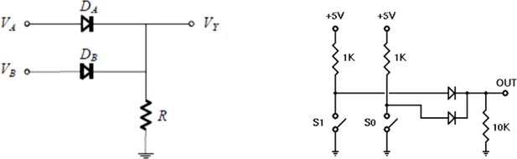

Fig. 1 DL OR Gate

Assuming the diodes are ideal, the voltage-based truth table as given in Table 1 (a) is obtained. The corresponding logic-based or binary truth table is given in Table 1 (b):

Table 1: (a) Voltage-based truth table, (b) Logic-based or binary truth table of DL OR gate

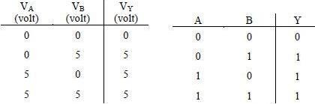

## ***Diode Logic AND Gate:***

A Diode Logic AND gate consists of diodes (one for each input signal) and a resistor. As with the DL OR gate, the 10KΩ resistor (R) provides a reference connection. Unlike the OR gate, however, this is a reference to +5 volts, rather than to ground. If there are no input signals connected to the diodes, the output will be +5 volts, or logic 1. Thus, an open input will not affect the rest of the circuit, which will continue to operate normally. As with DL-OR gates, it is possible to add any number of input diodes to this circuit, each with its separate input signal. However, two inputs are quite sufficient to demonstrate the operation of the circuit.

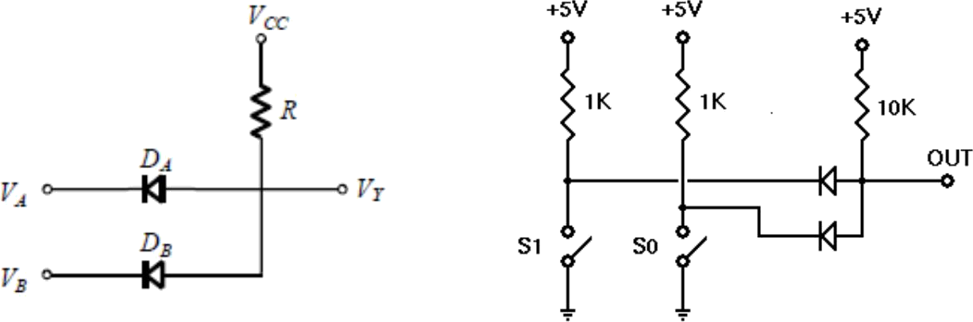

(a)

b)

Fig. 2 DL AND Gate

Assuming the diodes are ideal, the voltage truth table of the above AND gate is as given in Table 2 (a). The corresponding logic truth table is in Table 2(b).

Table 2: (a) Voltage-based truth table, (b) Logic-based or binary truth table of DL AND gate

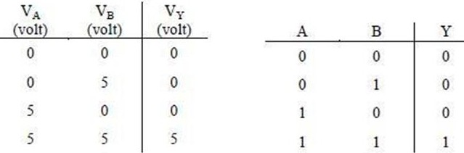

# Introduction:

A diode is a two-terminal electrical device that allows current to flow in one direction but not the other. It is like a pipe

with an internal valve that allows water to flow freely in one direction but shuts down if the water tries to flow in another direction. The diode’s two terminals are called the anode and cathode. In the diode symbol, the arrow points from the anode (the flat part of the triangle) toward the cathode (the point of the triangle).

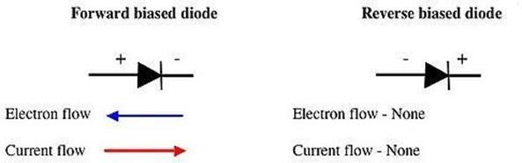

The device operates by allowing current to flow from the anode to the cathode, basically in the direction of the triangle. Recall that current is defined to flow from the more positive voltage toward the more negative voltage (electrons flow in the opposite direction). If the diode's anode is at a higher voltage than the cathode, the diode is said to be forward biased, its resistance is very low, and current flows. If the anode is at a lower voltage than the cathode, the diode is reverse-biased, its resistance is very high, and no current flows. The diode is not a perfect conductor, so there is a small voltage drop, approximately 0.7 V, across it.

In this group of experiments, we will implement some logic functions using the DL circuits and discover the potential benefits and problems of using the DL logic.

# Apparatus:

1. 10 k ohm resistor (Color band: brown-black-orange).
2. 1N914/1N4002 diodes or equivalent.
3. Connecting wires.
4. Trainer Board

**Precautions:**

All connections should be checked by the instructor after the circuit has been set up. It must be ensured that the correct voltage (within VCC limits) is applied to activate the diodes, transistors, and/or chips; otherwise, damage may occur to the components.

# Experimental Procedure:

1.The DL-OR gate should be constructed on the breadboard as shown in Fig. 1. A truth table similar to the one provided should then be drawn, and the experimental results should be filled in accordingly.

2. The DL-AND gate should be constructed on the breadboard as shown in Fig. 2. A truth table similar to the one provided should then be drawn, and the experimental results should be recorded.

# Results and Discussions:

In this experiment, students built basic logic gates using diodes and transistors to understand Diode and Transistor Logic (DTL). The gates were tested and outputs compared with expected truth tables. Overall, the experiment was successful in demonstrating correct logic behavior.

Some errors occurred due to wrong connections or faulty components, which affected results. Improvements could include better circuit checking, using reliable components, and simulating the circuits beforehand. Despite minor issues, the experiment met its goal and helped reinforce practical digital logic concepts.

# Part 2: Construction of Bipolar Transistor Logic Gate

**Theory and Methodology:**

## ***Resistor-Transistor Logic (RTL):***

Resistor-Transistor Logic (RTL) is a large step beyond Diode Logic (DL). Basically, RTL replaces the diode switch with a transistor switch. If a +5 V signal (logic 1) is applied to the base of the transistor (through an appropriate resistor to limit base-emitter forward voltage and current), the transistor turns fully on and grounds the output signal. If the input is grounded (logic 0), the transistor is off and the output signal is allowed to rise to + 5 V. In this way, the transistor not only inverts the logical sense of the signal but also ensures that the output voltage will always be a valid logic level under all circumstances. Because of this, RTL circuits can be cascaded indefinitely, whereas DL circuits cannot be cascaded reliably at all.

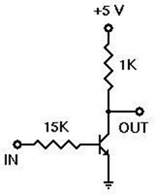

Fig. 4: RTL Inverter

## ***Diode-Transistor Logic (DTL):***

Diode-Transistor Logic (DTL) is a class of digital circuits built from Bipolar Junction Transistors (BJT), diodes, and resistors; it is the direct ancestor of Transistor–Transistor Logic (TTL). DTL offers better noise margins and greater fan-outs than RTL but suffers from low speed (especially in comparison to TTL). RTL allows the construction of NOR gates easily, but NAND gates are relatively more difficult to get from RTL. DTL, however, allows the construction of simple NAND gates from a single transistor, with the help of several diodes and resistors.

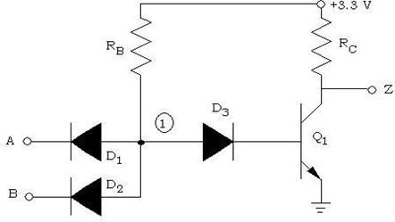

Fig. 5: 2-input DTL NAND Gate

## ***Transistor-Transistor Logic:***

We can think of a bipolar transistor as two diodes placed very close together, with the point between the diodes being the transistor base. Thus, we can use transistors in place of diodes to obtain logic gates that can be implemented with transistors and resistors only; this is called Transistor-Transistor Logic (TTL).

One problem that DTL doesn't solve is its low speed, especially when the transistor is being turned off. Turning off a saturated transistor in a DTL gate requires it to first pass through the active region before going into cut-off. Cut-off, however, will not be reached until the stored charge in its base has been removed. The dissipation of the base charge takes time if there is no available path from the base to the ground. This is why some DTL circuits have a base resistor that's tied to the ground, but even this requires some trade-offs. Another problem with turning off the DTL output transistor is the fact that the effective capacitance of the output needs to charge up through *Rc* before the output voltage rises to the final logic '1' level, which also consumes a relatively large amount of time. TTL, however, solves the speed problem of DTL elegantly.

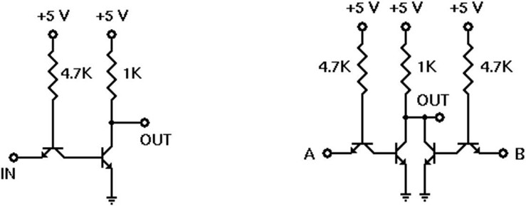

Fig. 6: TTL Inverter

**BJT Pin Configuration:**

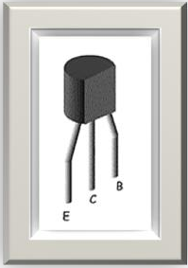

# Introduction:

A bipolar transistor is a three-terminal semiconductor device. Under the control of one of the terminals, called the base, current can flow selectively from the collector terminal to the emitter terminal.

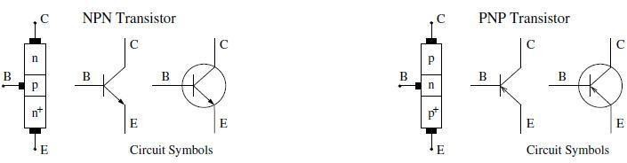

Fig. 3: Bipolar Junction Transistor (BJT) circuit symbols

In this experiment, we examine how to build logic gates from Bipolar Junction Transistors (BJT) using the RTL, DTL, and TTL design.

# Apparatus:

* 1. 2N4124 NPN silicon transistor (or equivalent).
  2. Resistors (15 kΩ, 1 kΩ, 4.7 kΩ)
  3. Connecting wires.
  4. Trainer Board

**Precautions:**

All connections should be checked by the instructor after the circuit has been set up. The appropriate voltage (within VCC) should be applied to ensure the transistors and/or chip are turned on. Otherwise, damage may be caused to the components.

# Experimental Procedures:

(1) The circuit for the RTL inverter should be set up as shown in Fig. 6.  
(2) For each input combination, the output should be determined and recorded in a Truth Table. Two sets of outputs—one ideal and one experimental—should be included in the Truth Table.  
(3) Steps 1 and 2 should be repeated for the circuit set-ups shown in Figs. 7 and 8.

**Lab Measurement:**

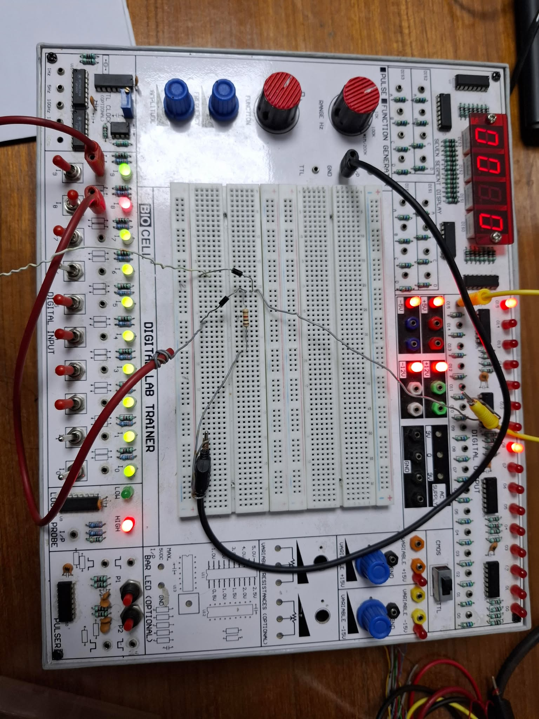

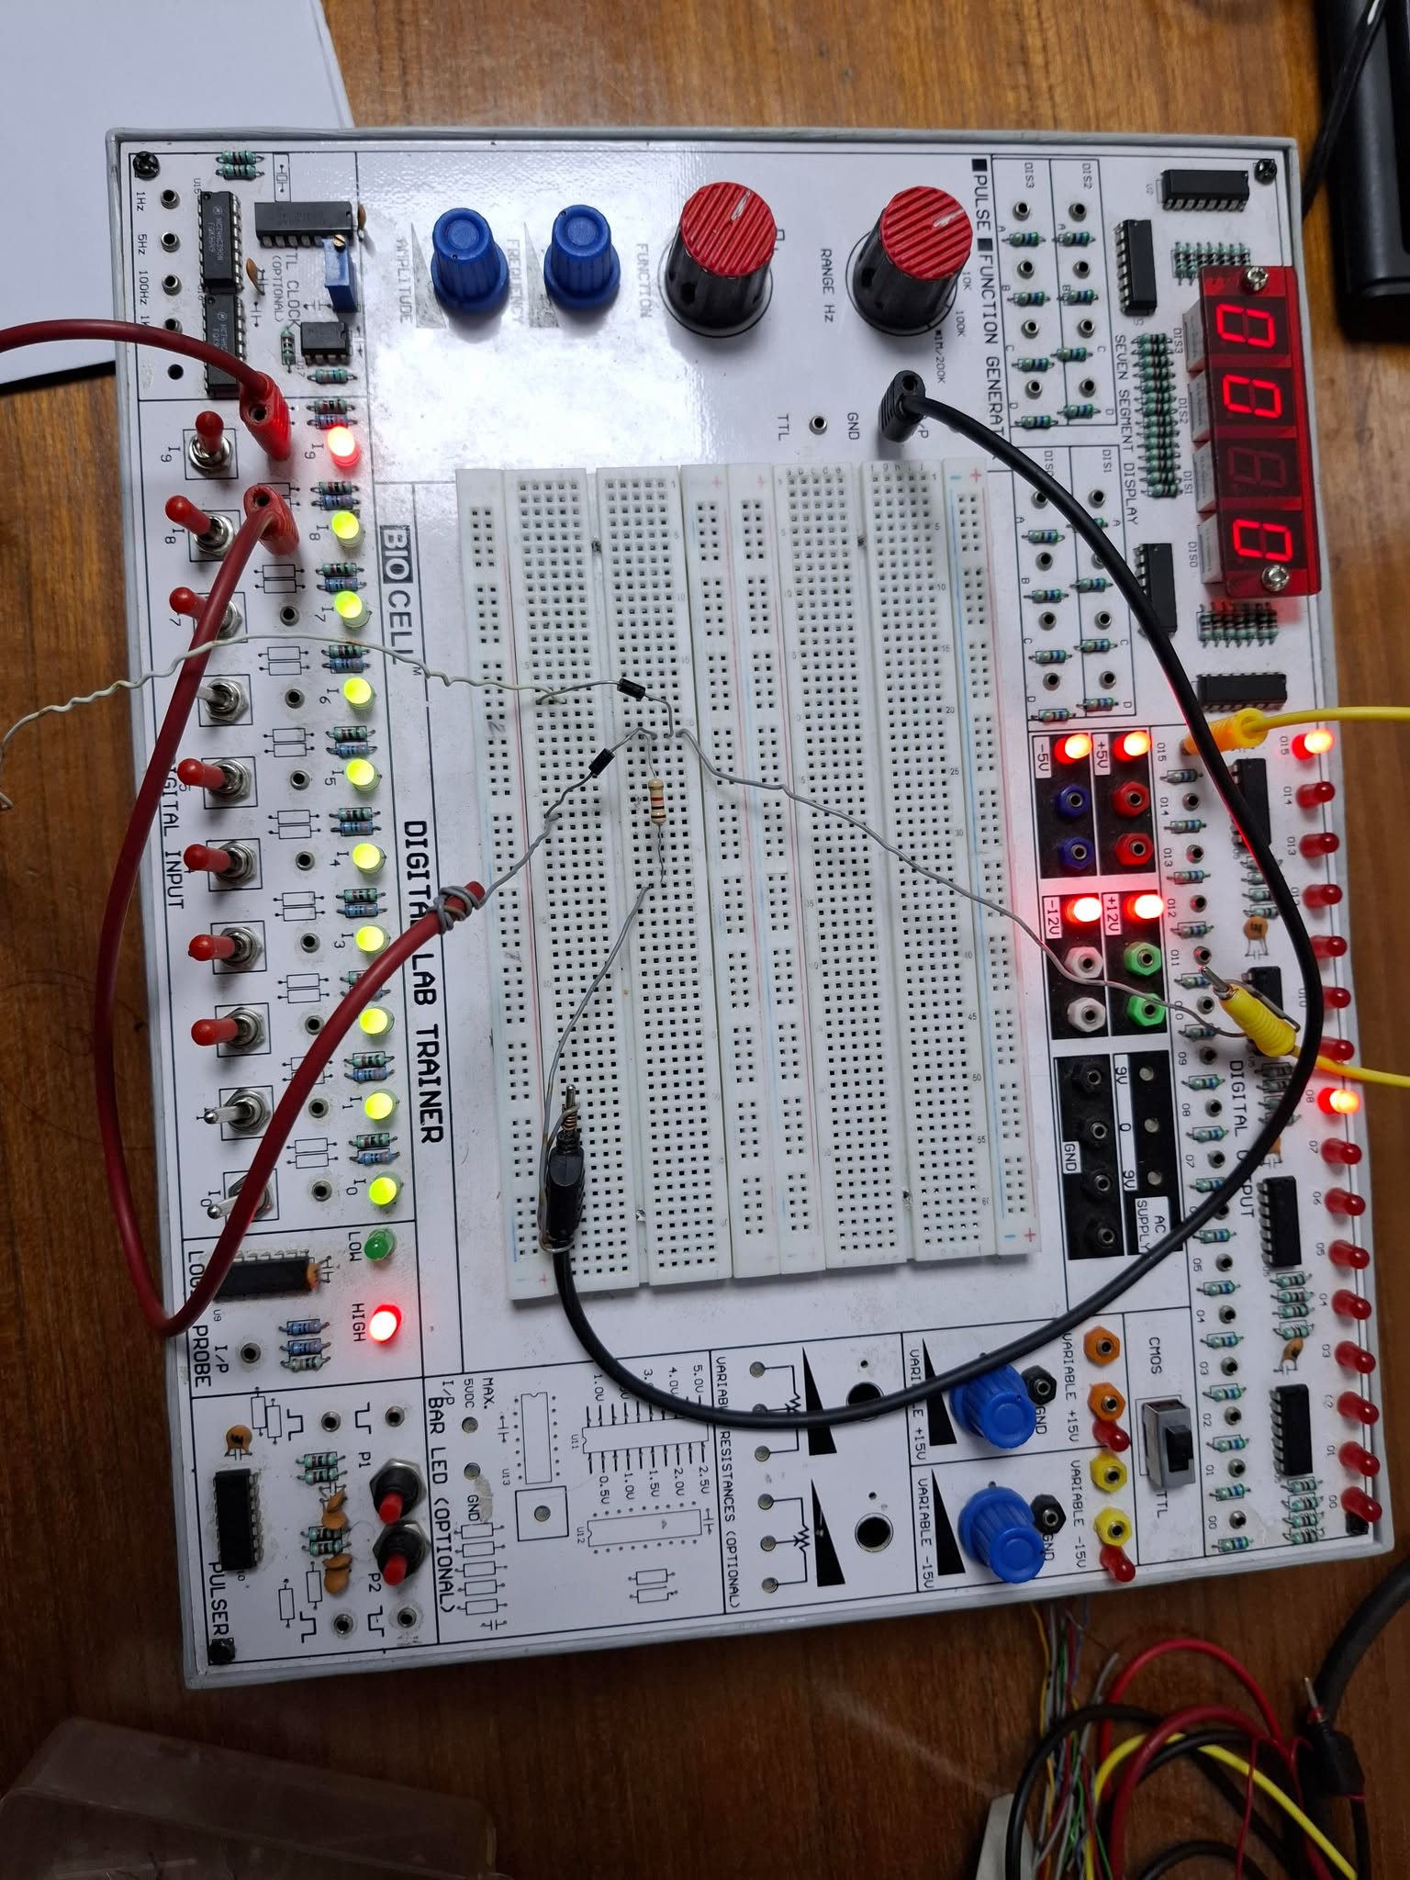

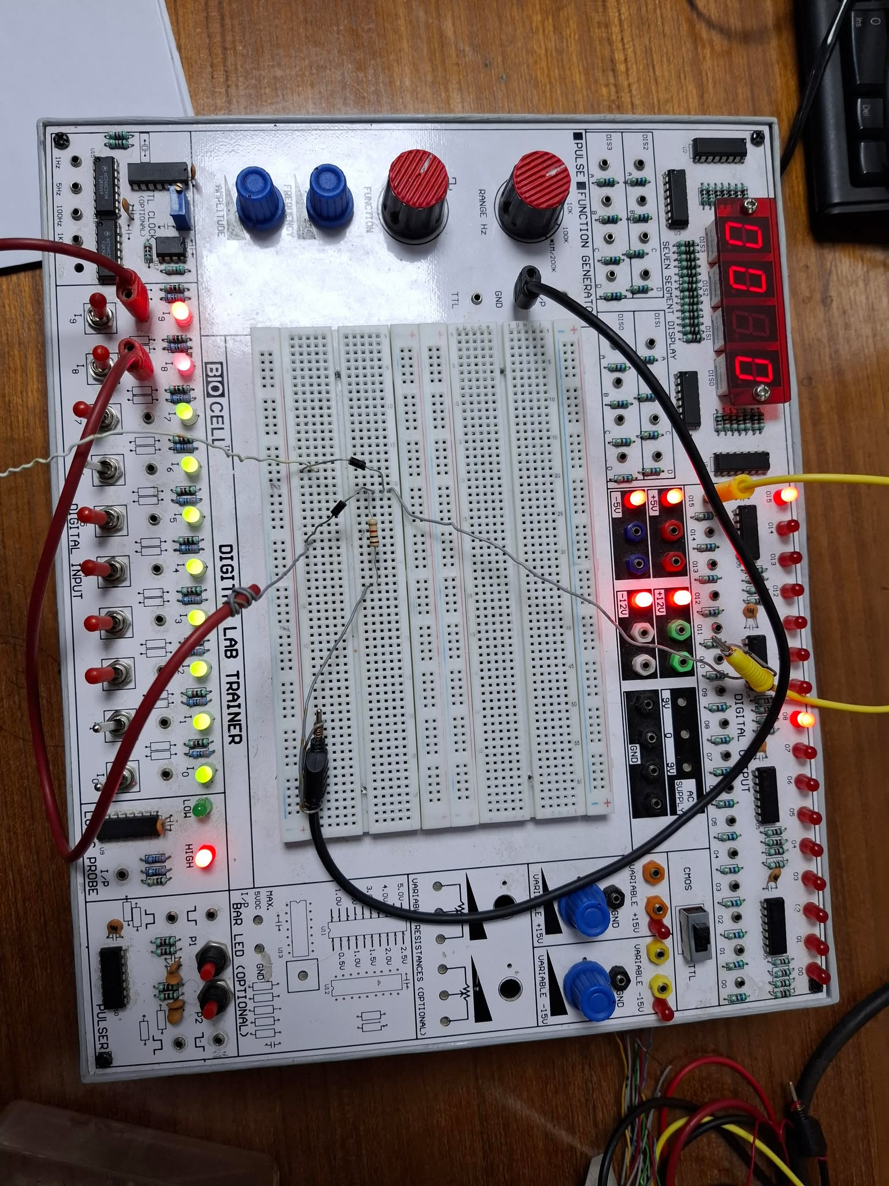

Fig. 1 DL OR Gate

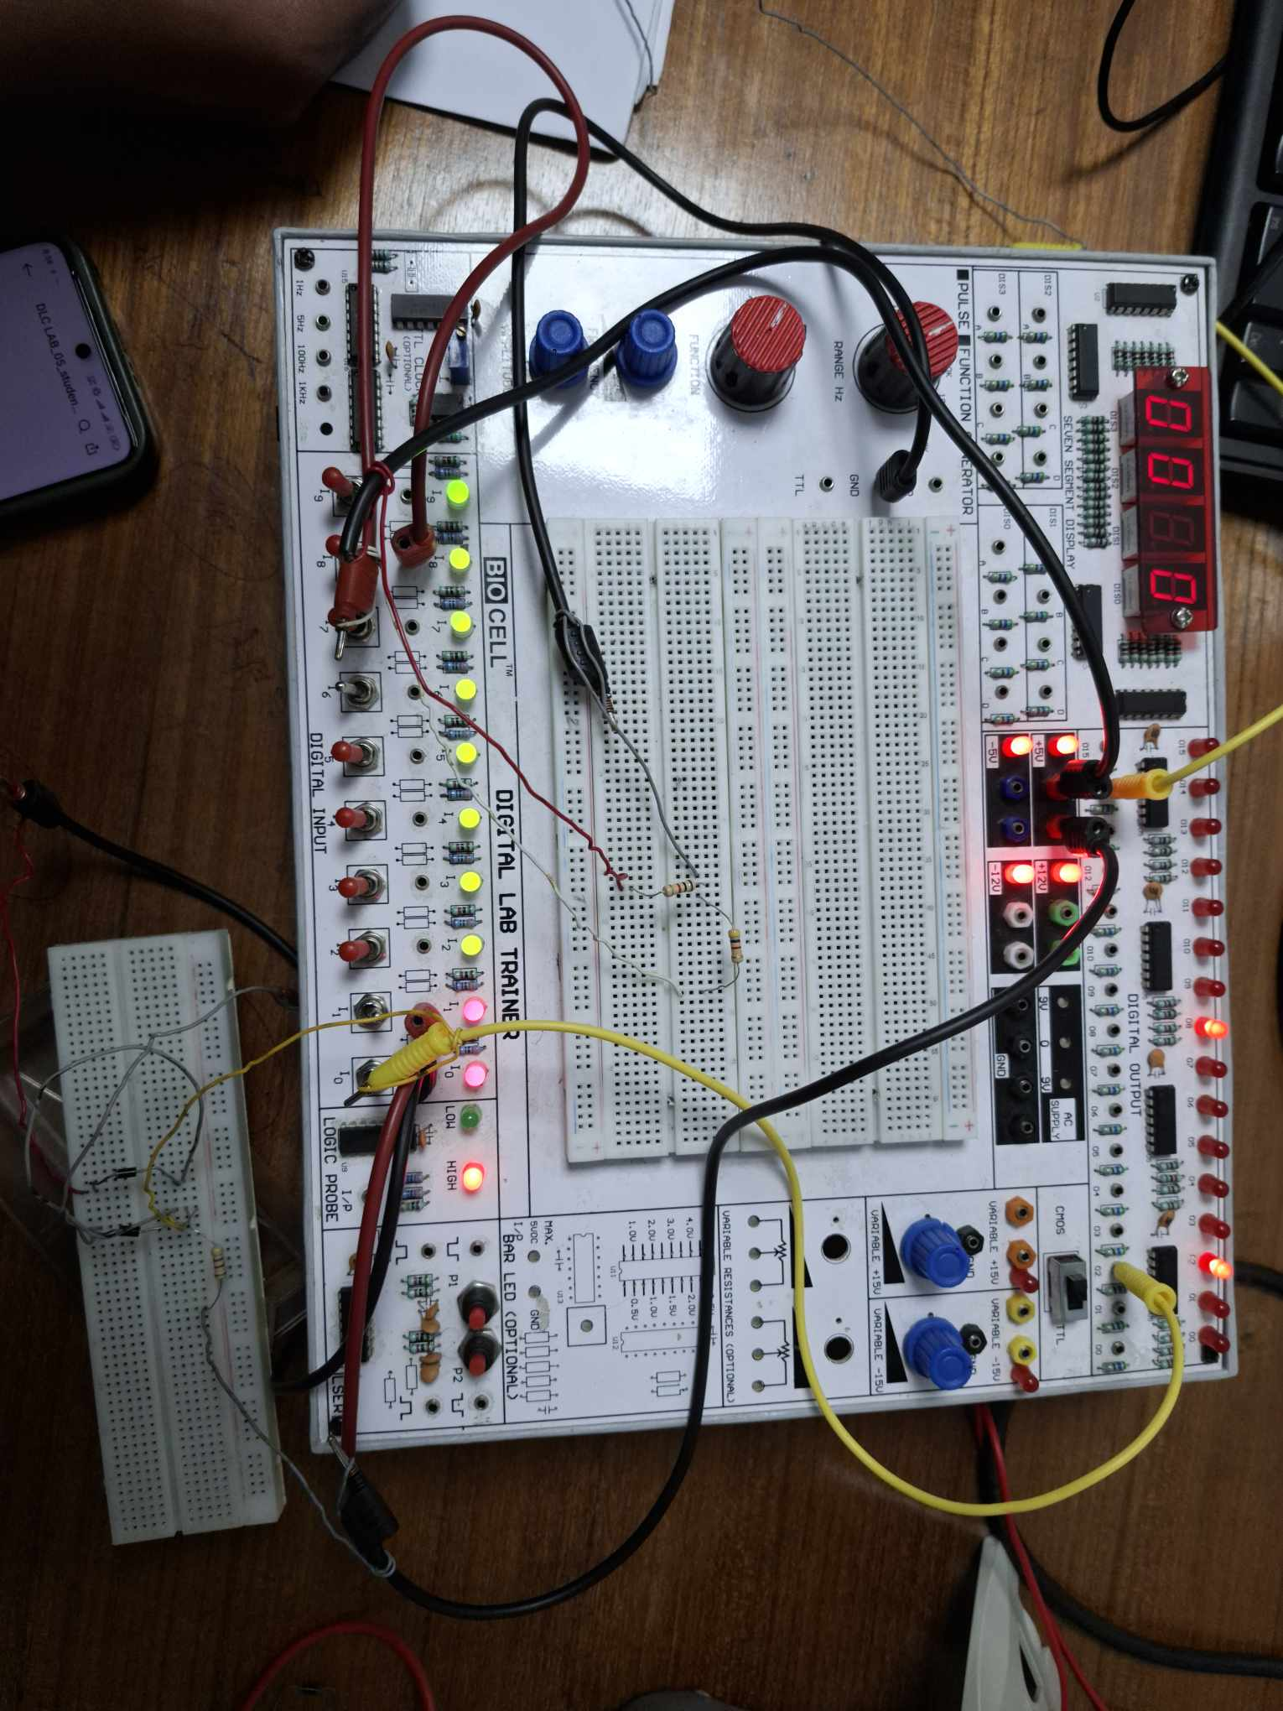

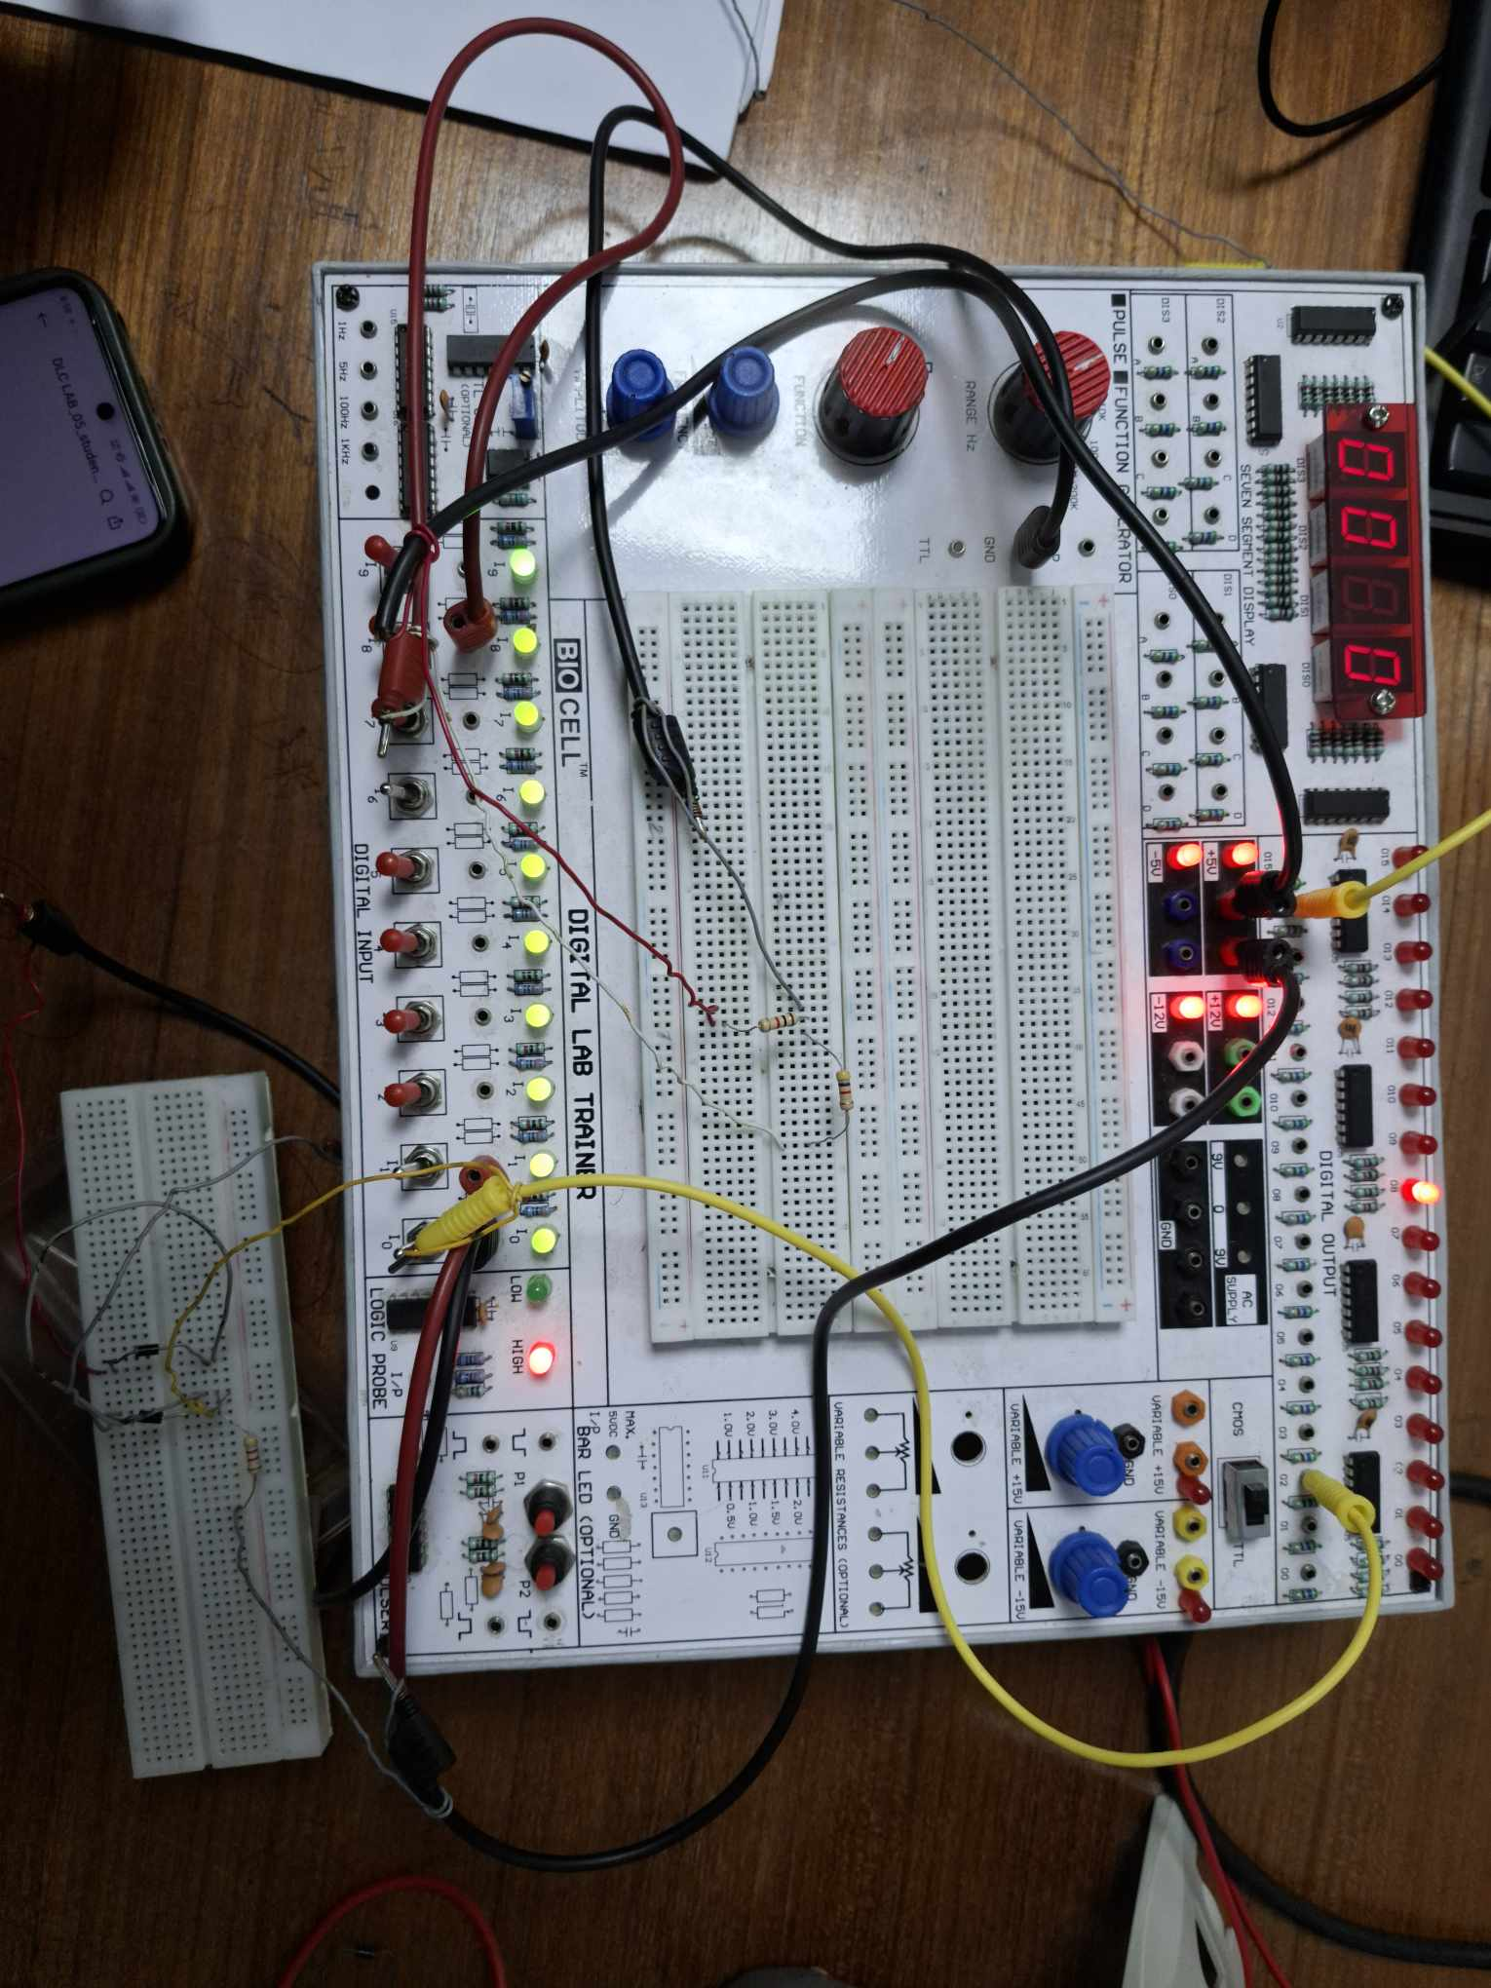

Fig. 2 DL AND Gate

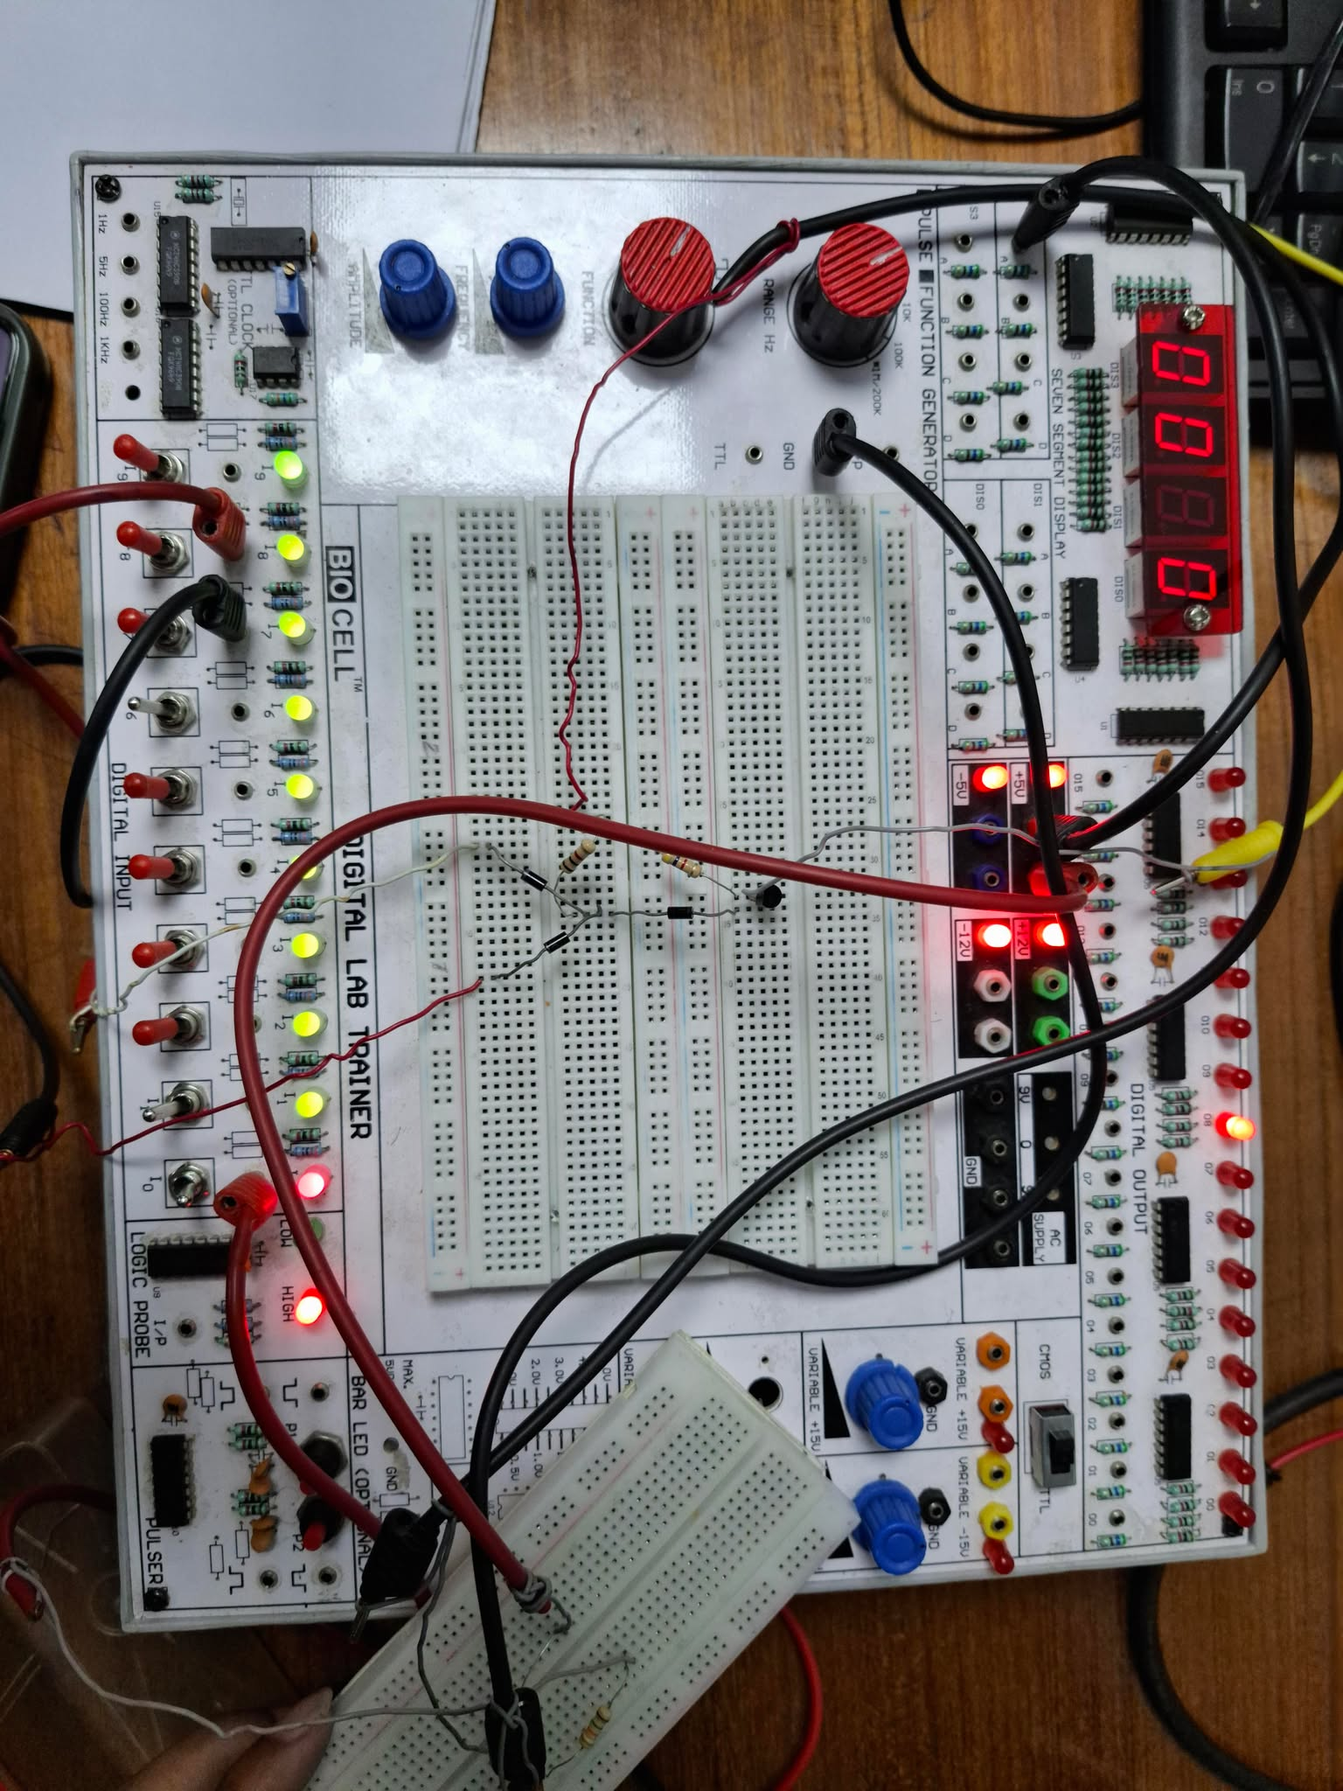

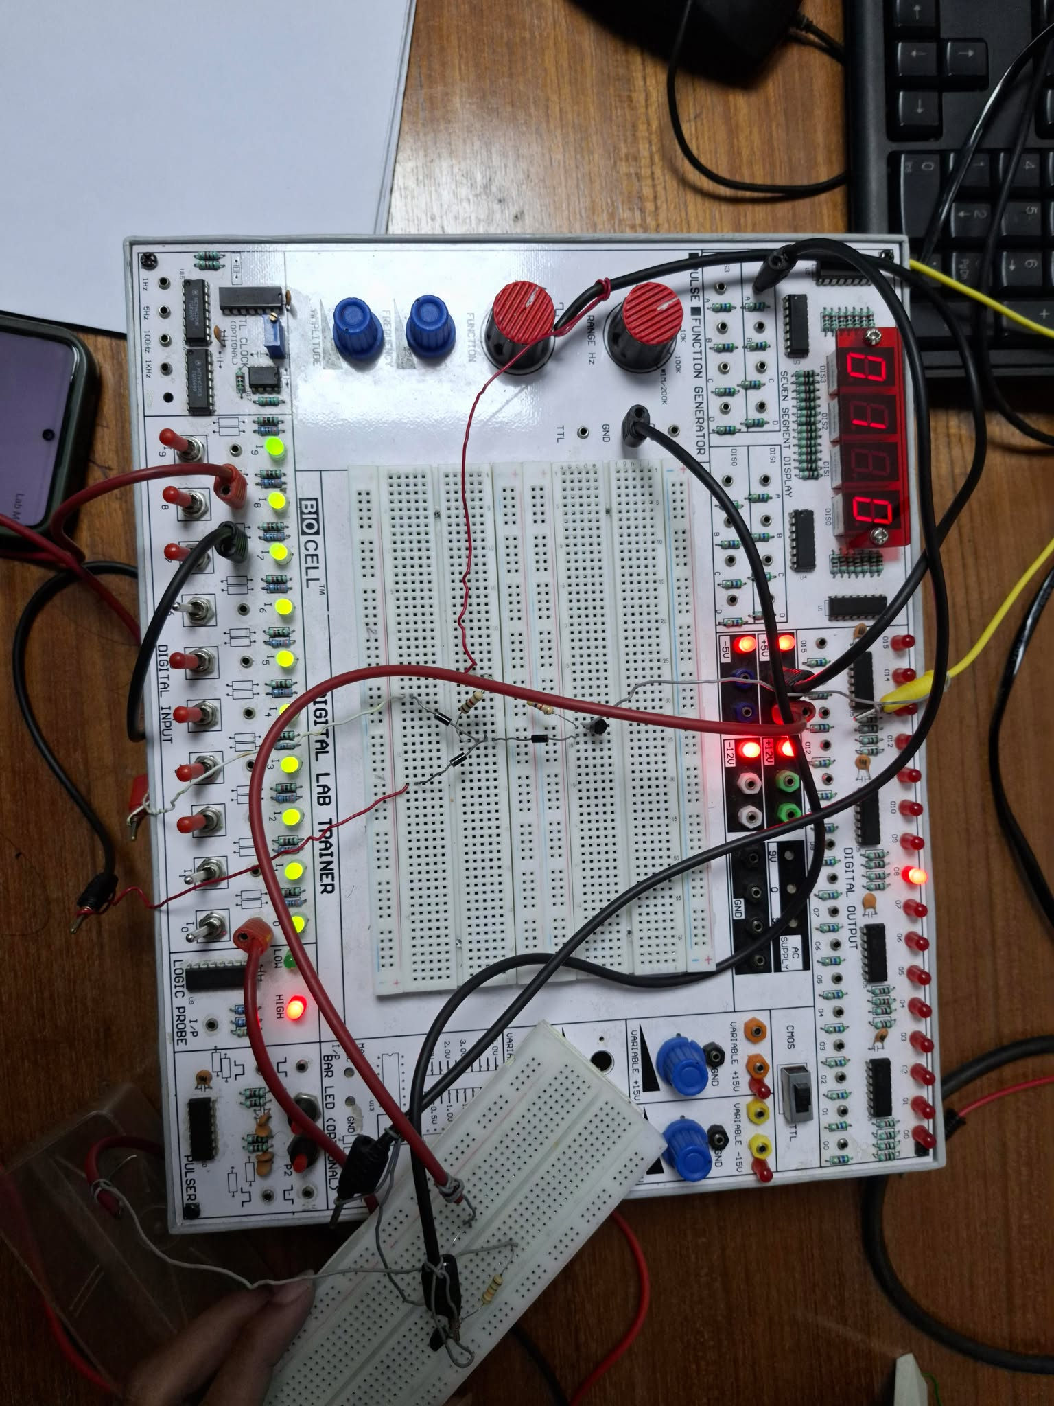

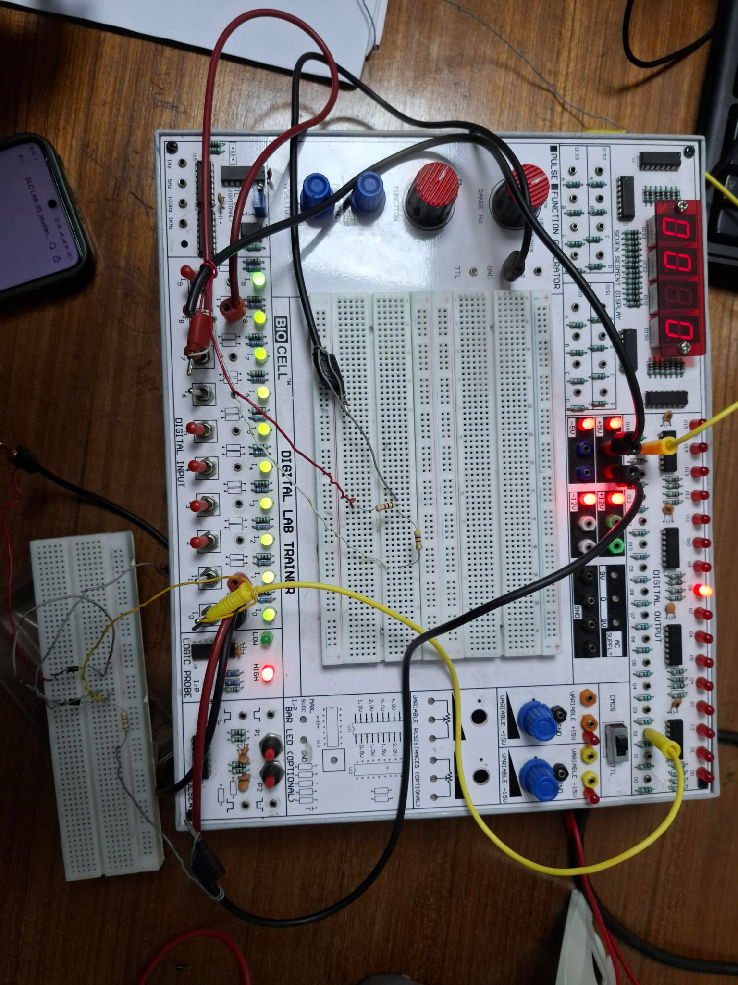

Fig. 4: RTL Inverter

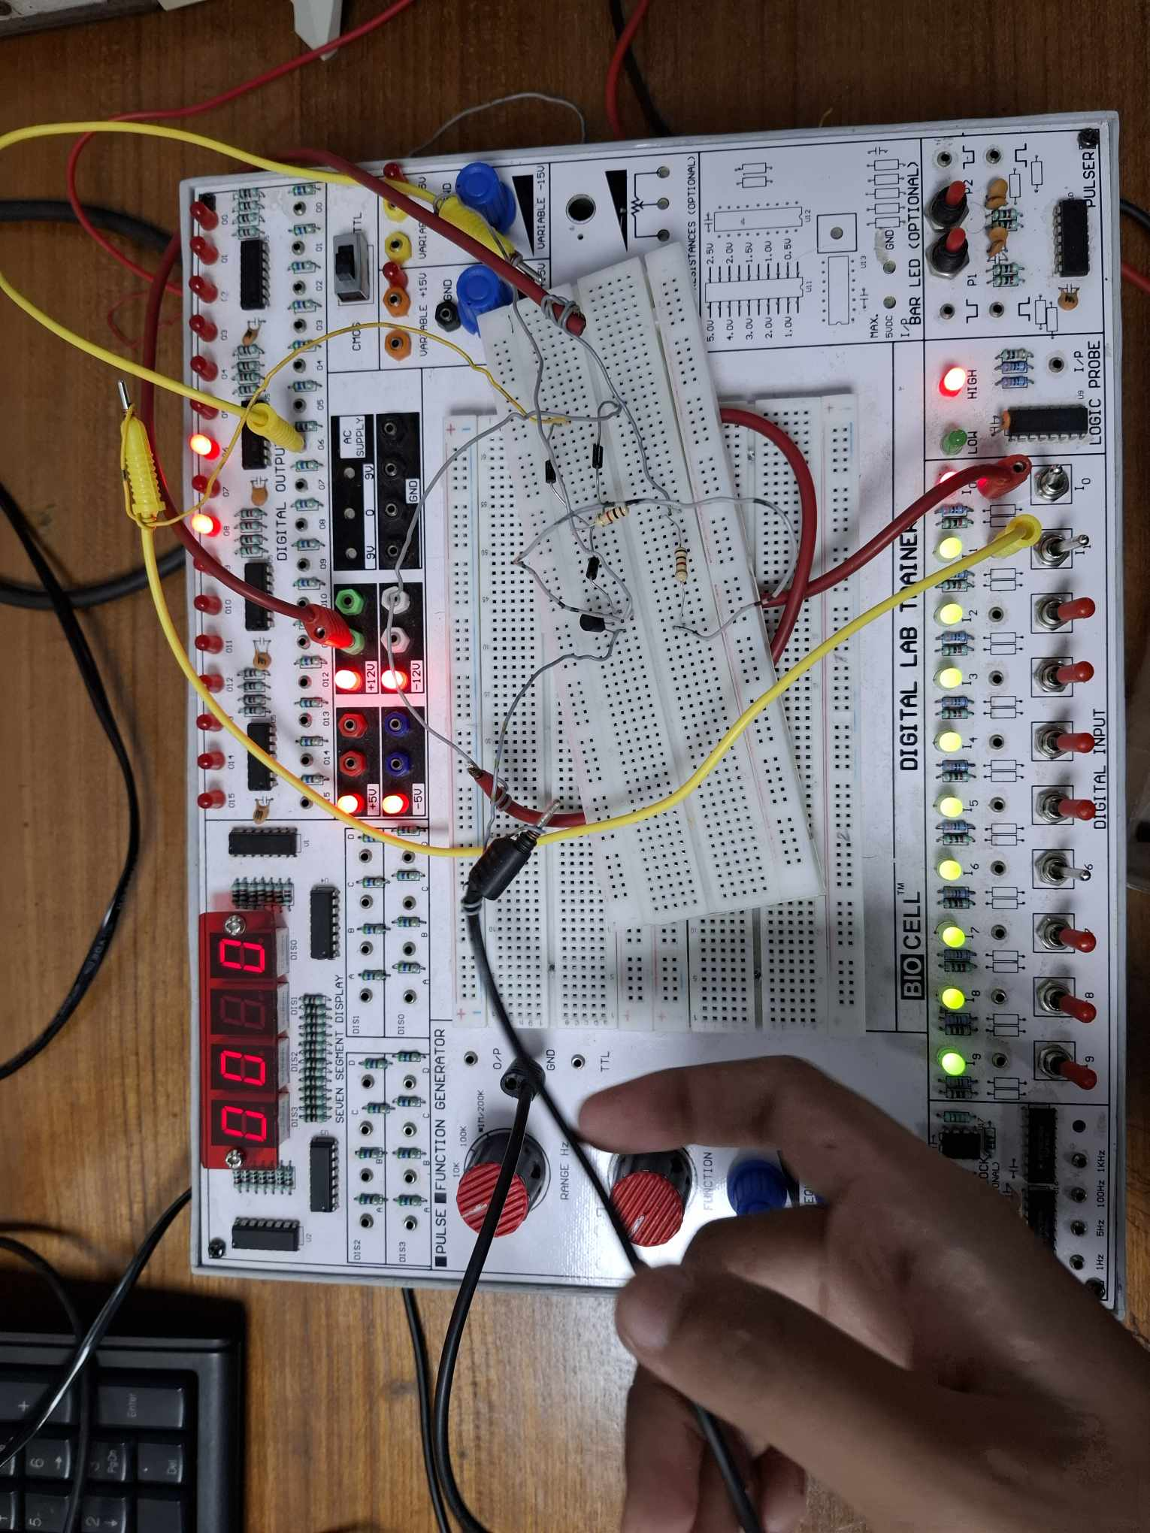

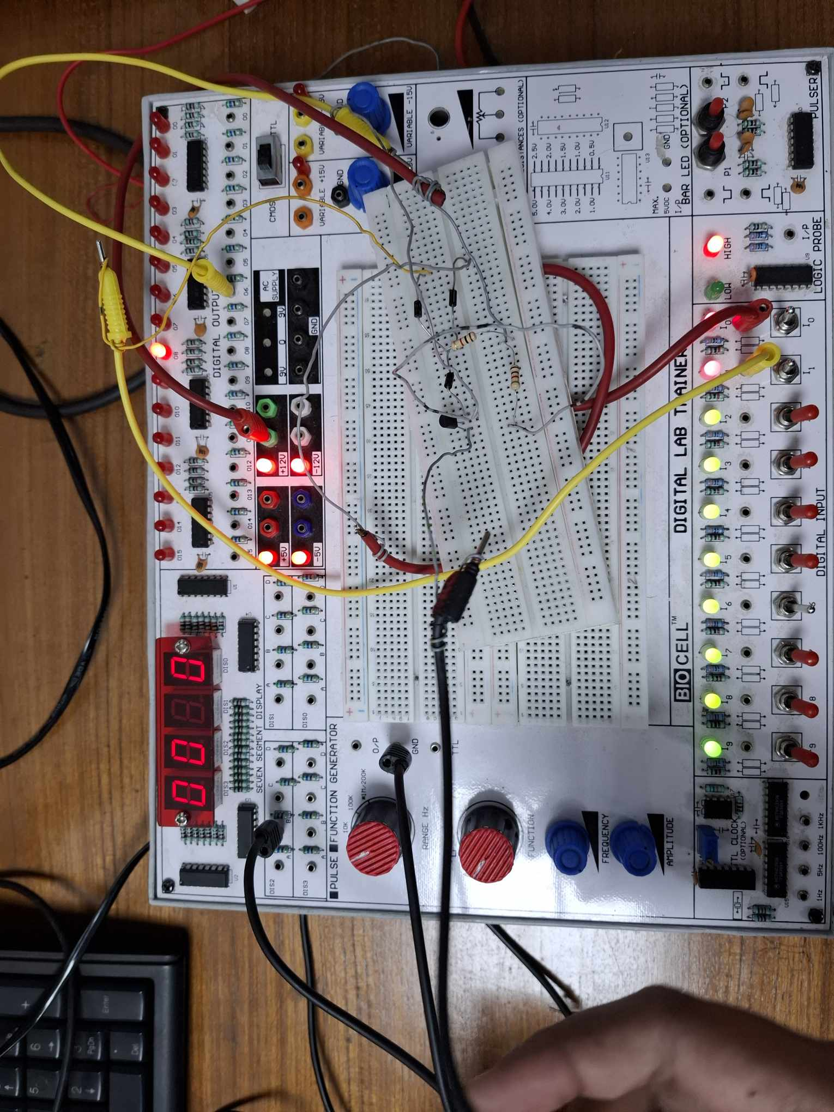

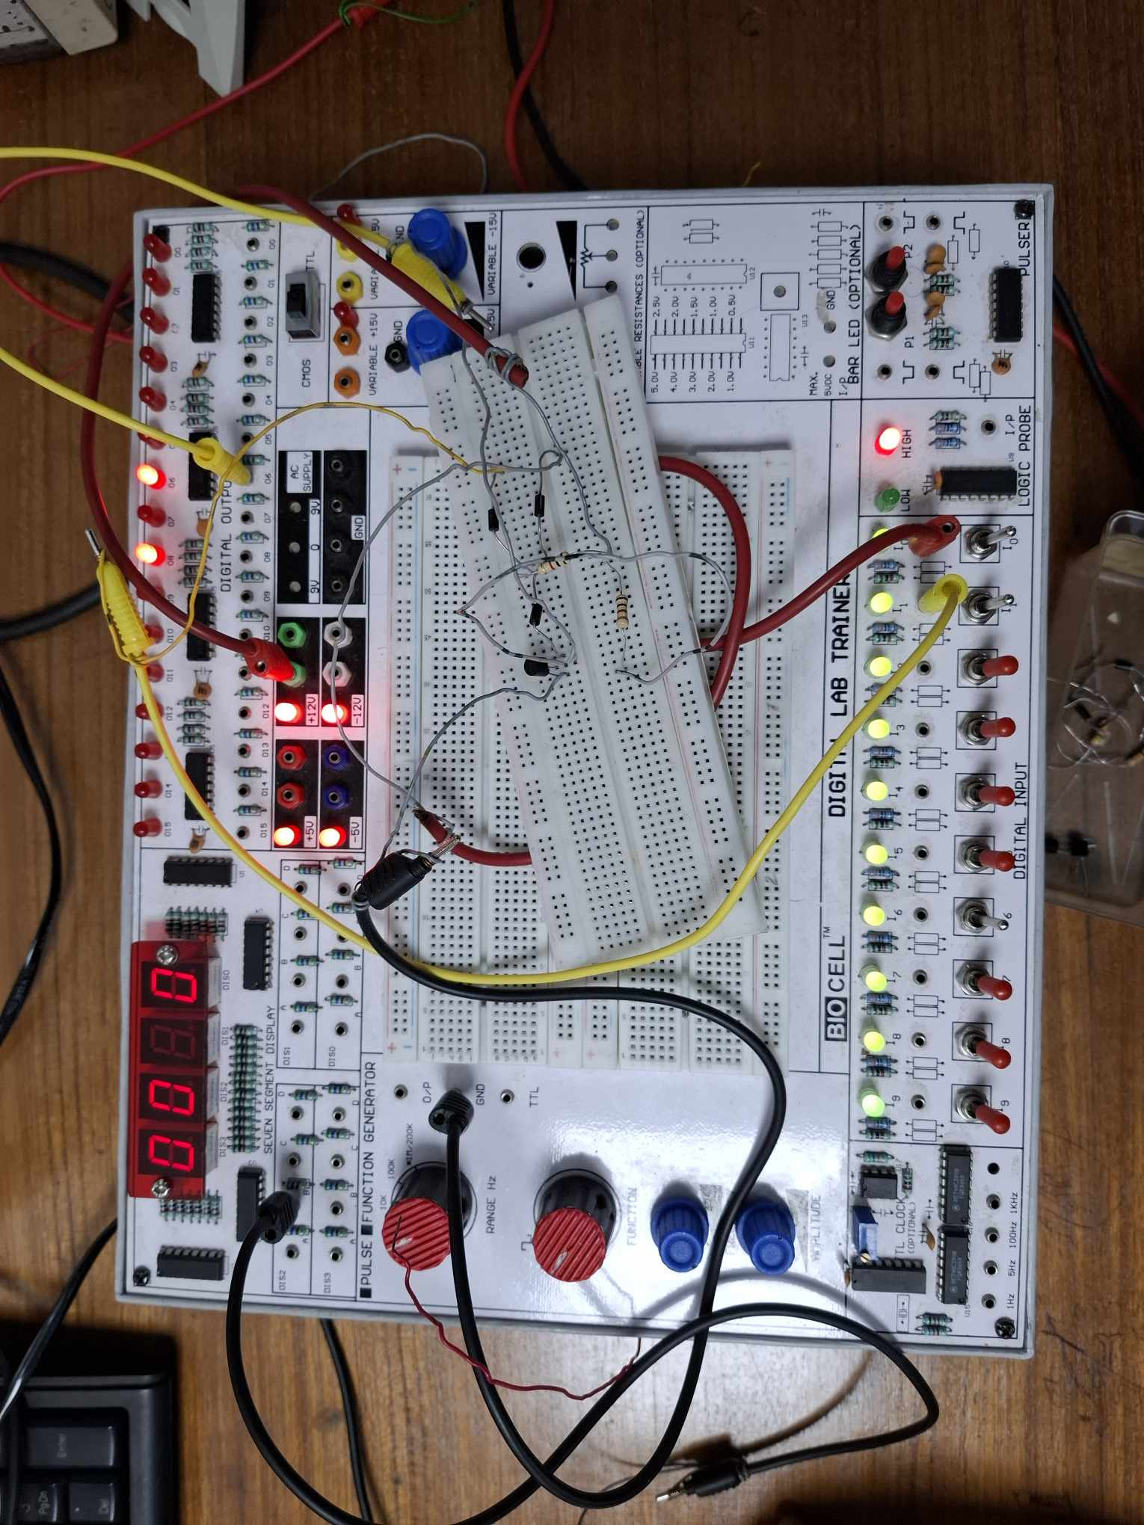

Fig. 5: 2-input DTL NAND Gate

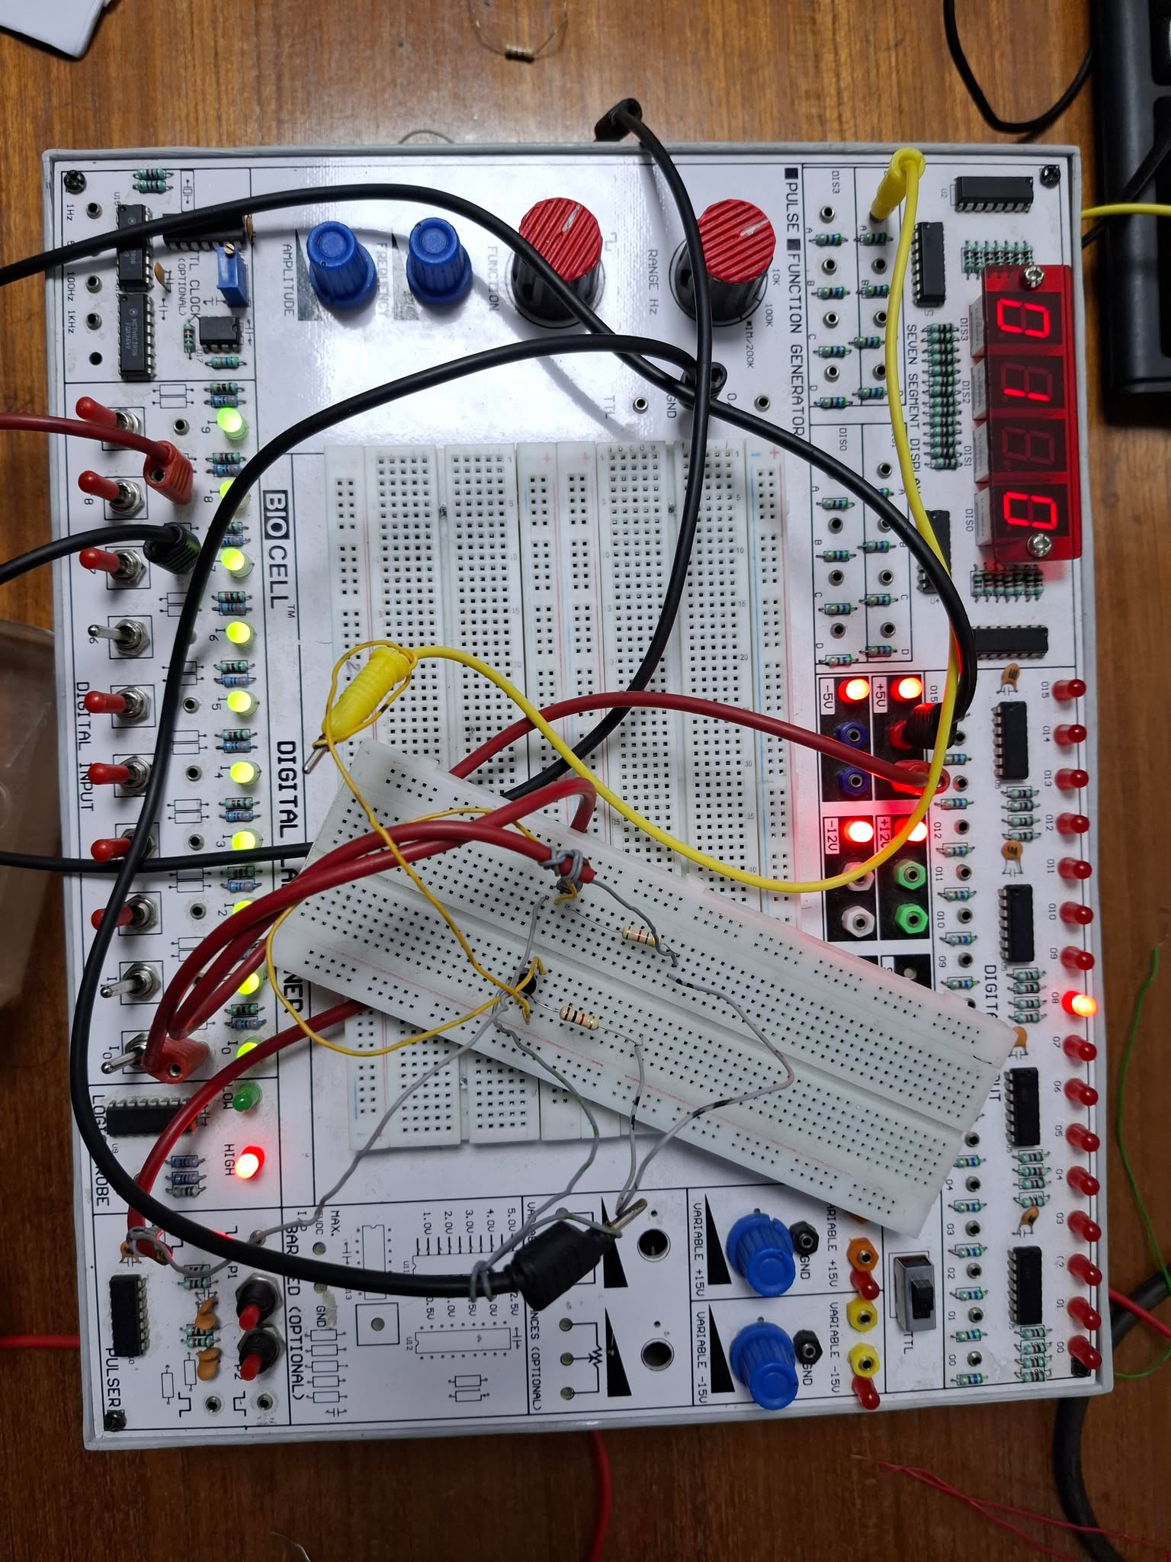

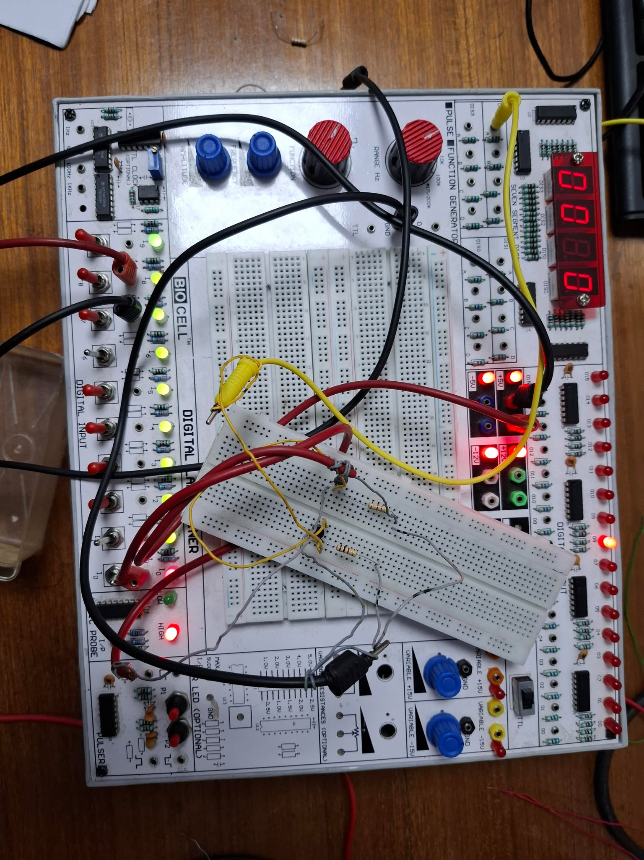

Fig. 6: TTL Inverter

**Simulation**

1 DL OR Gate

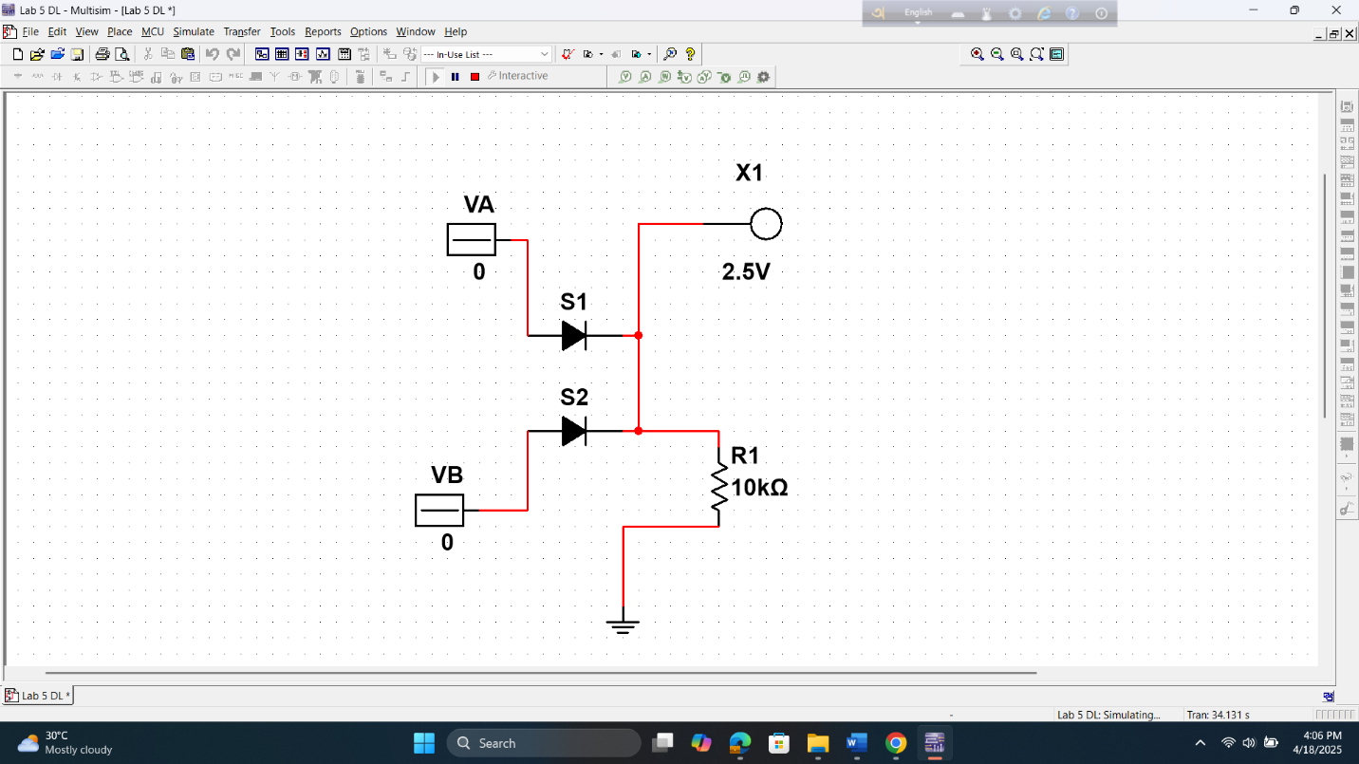

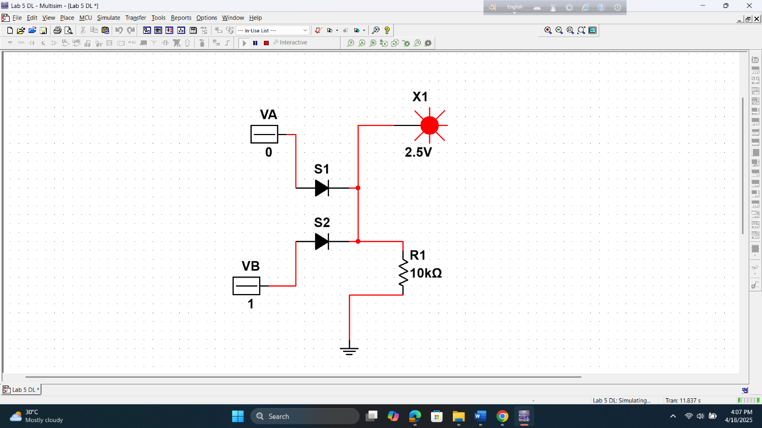

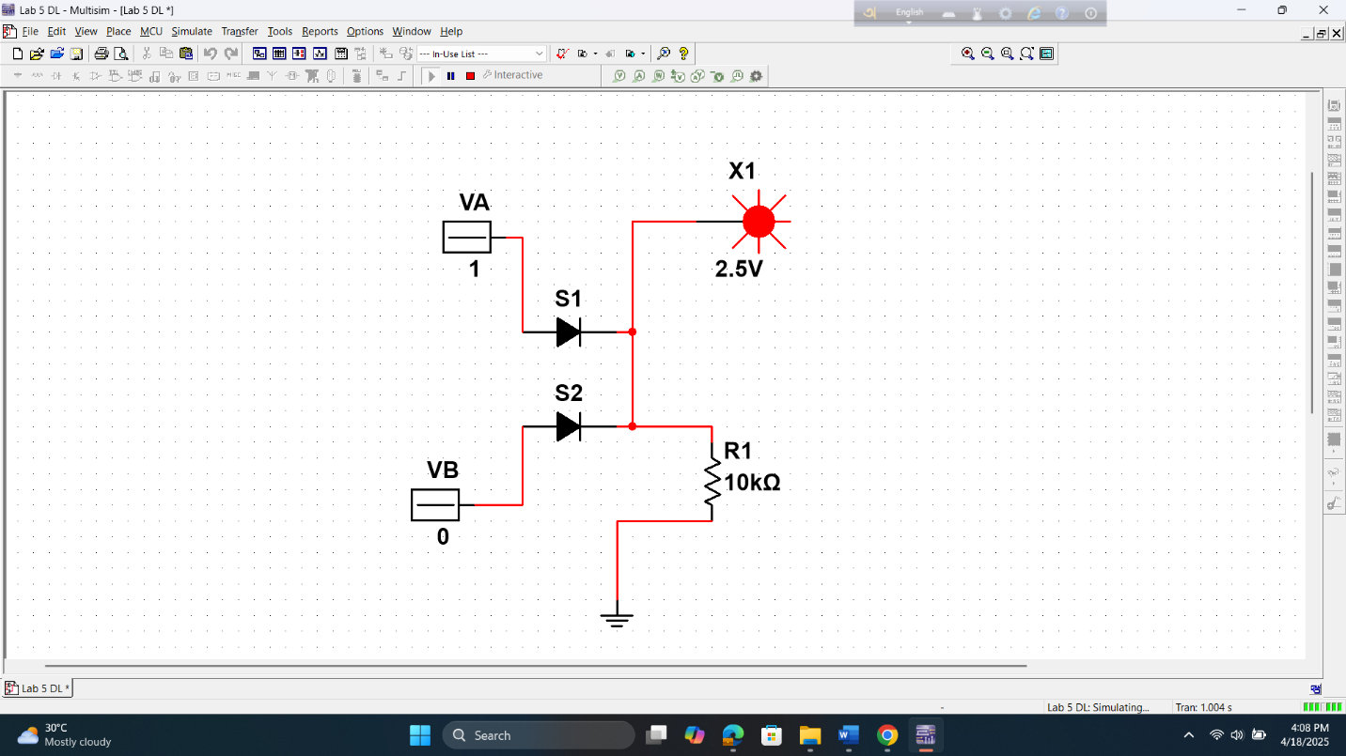

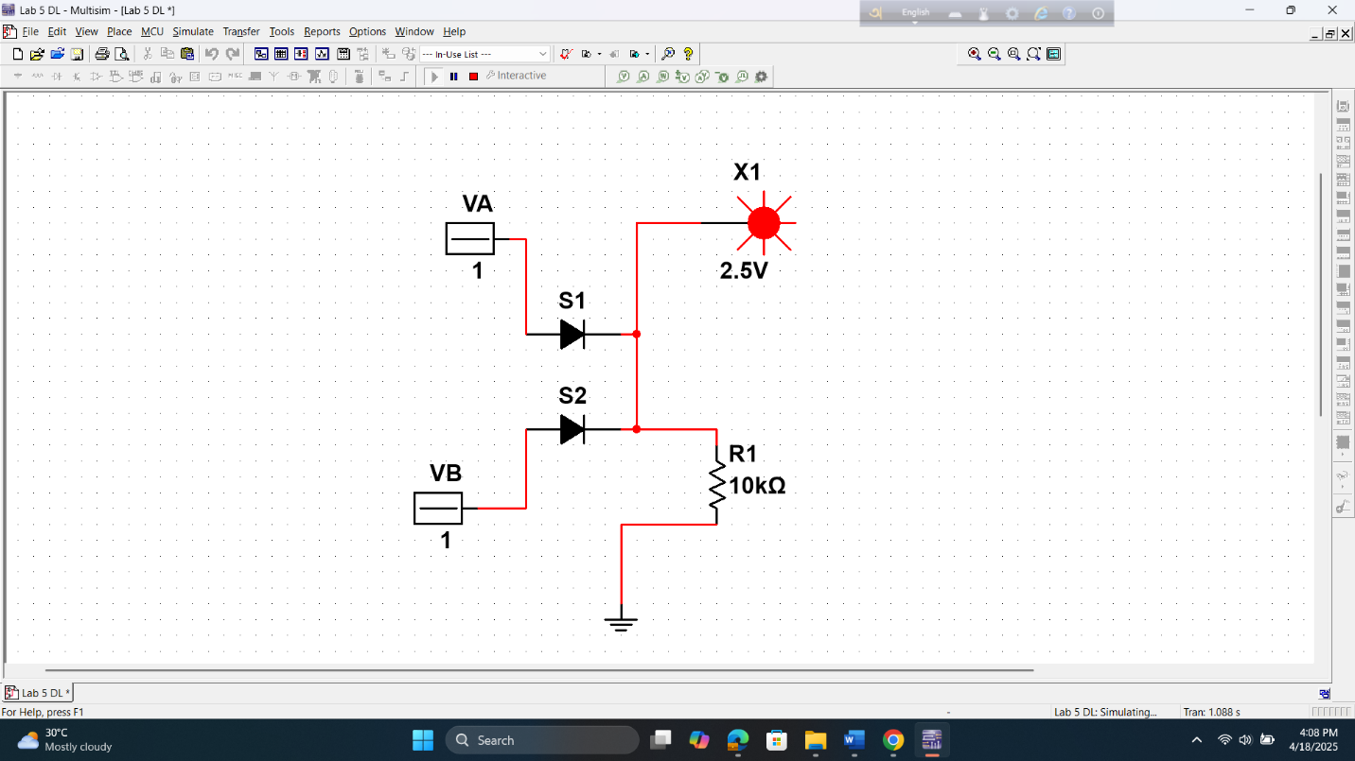

2 DL AND Gate

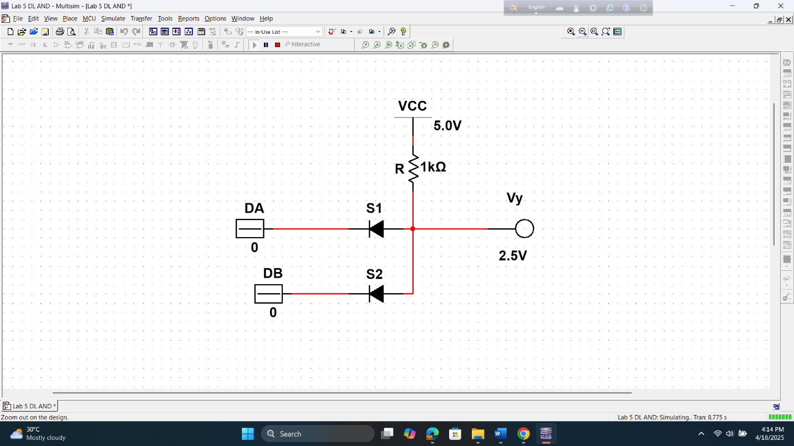

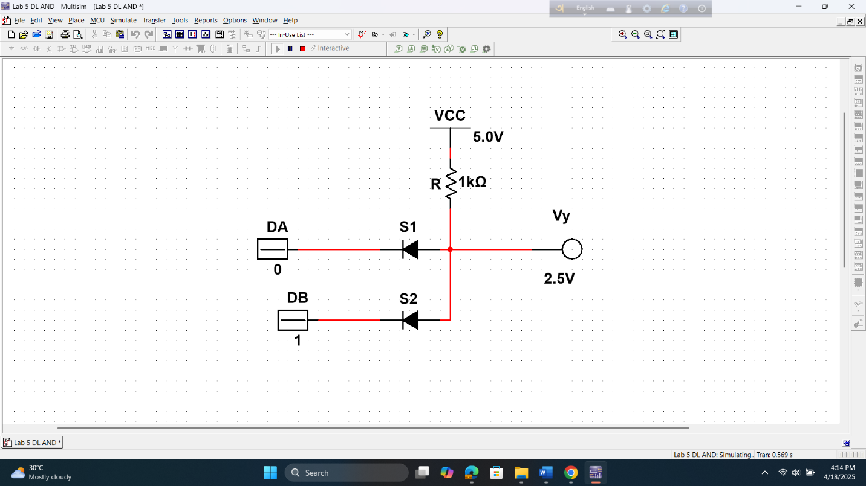

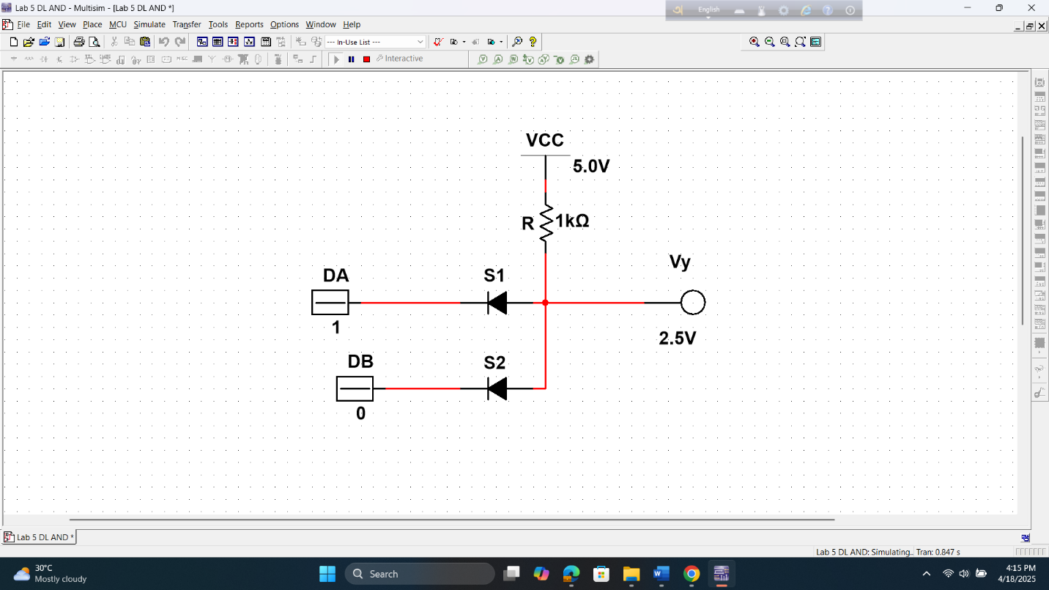

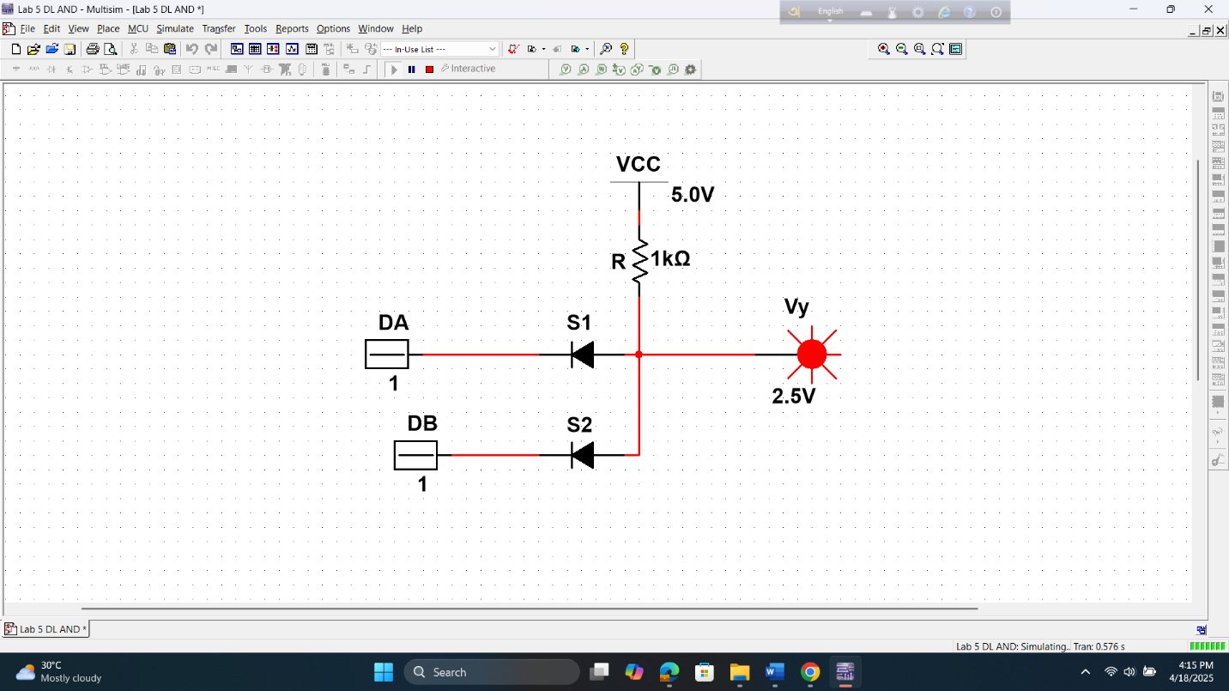

RTL Inverter

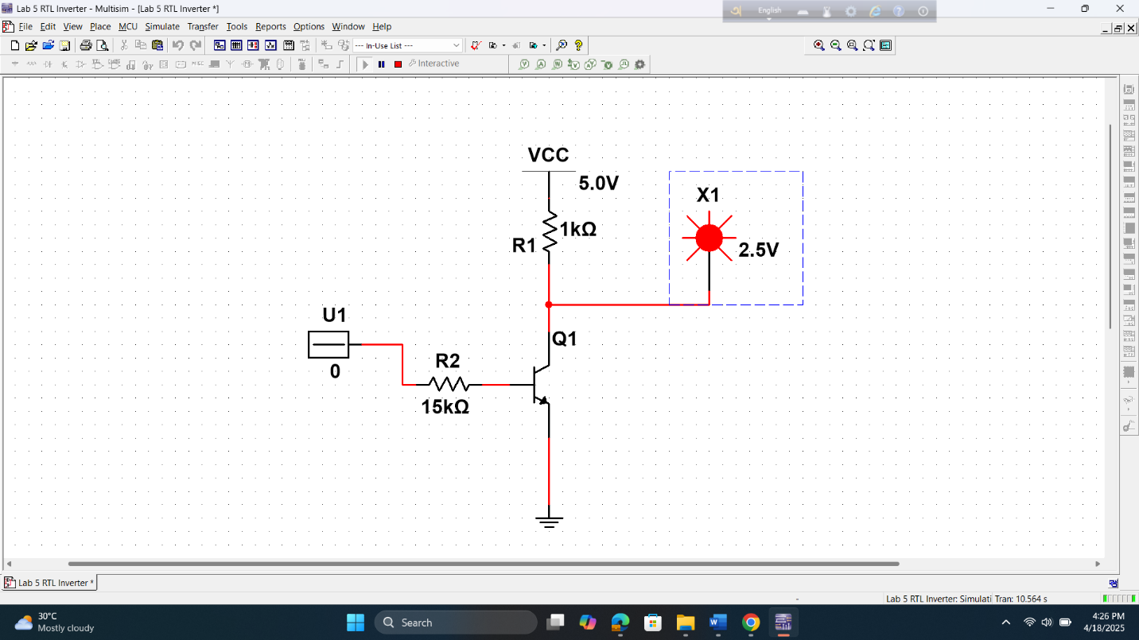

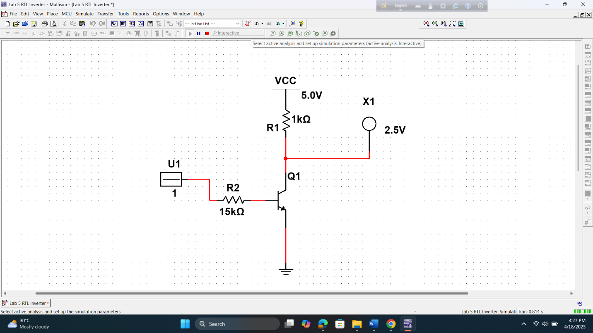

2-input DTL NAND Gate

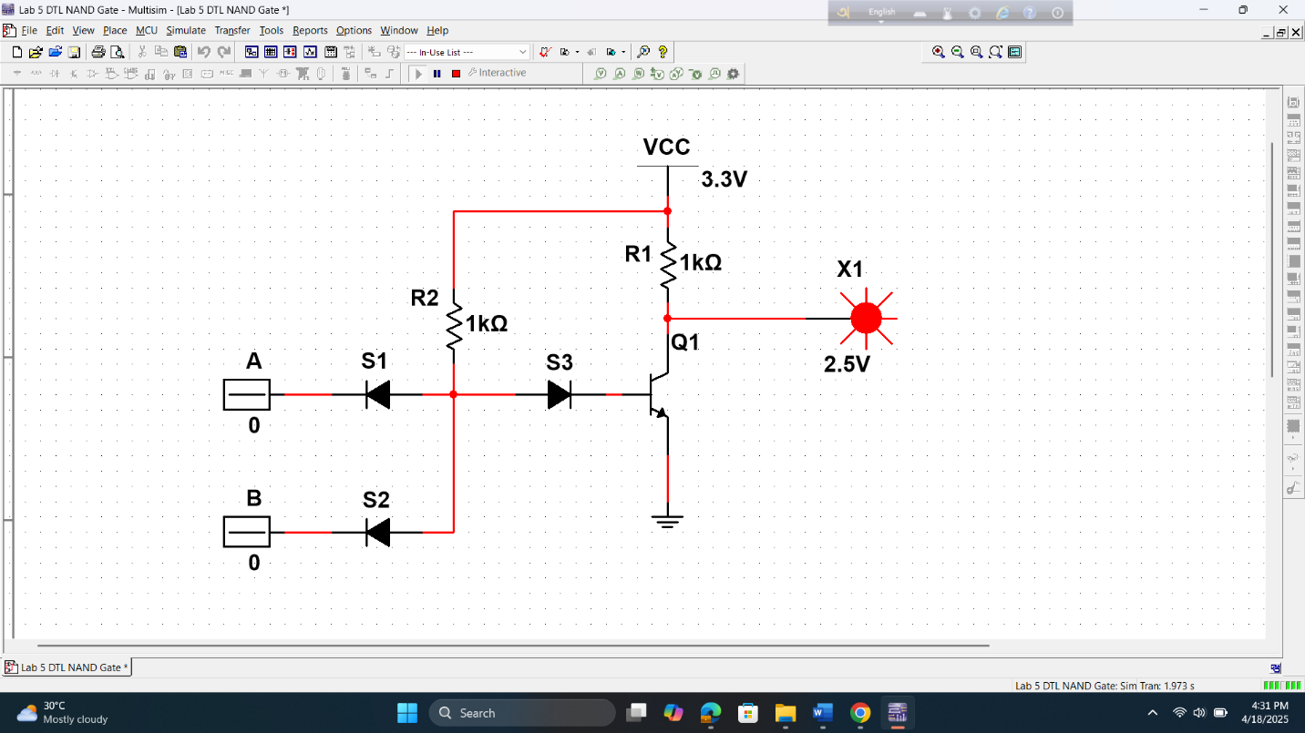

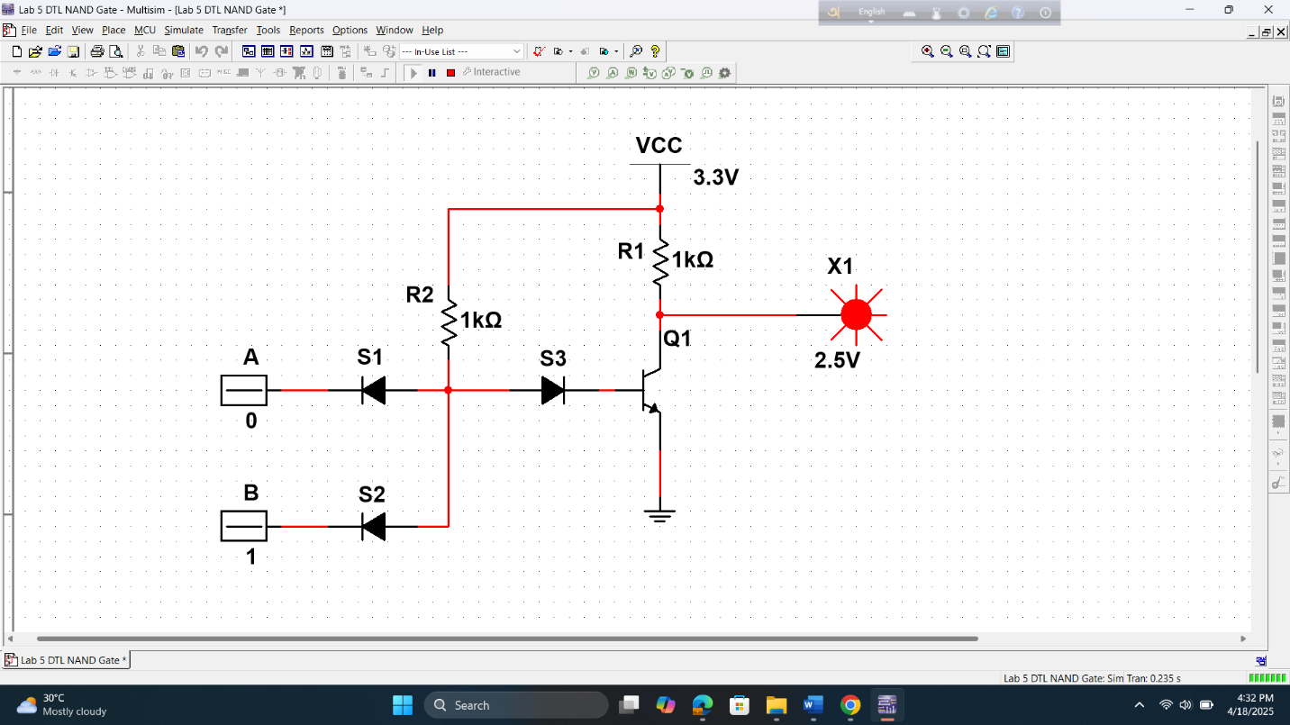

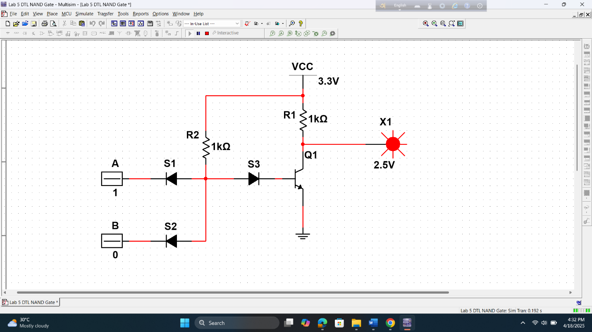

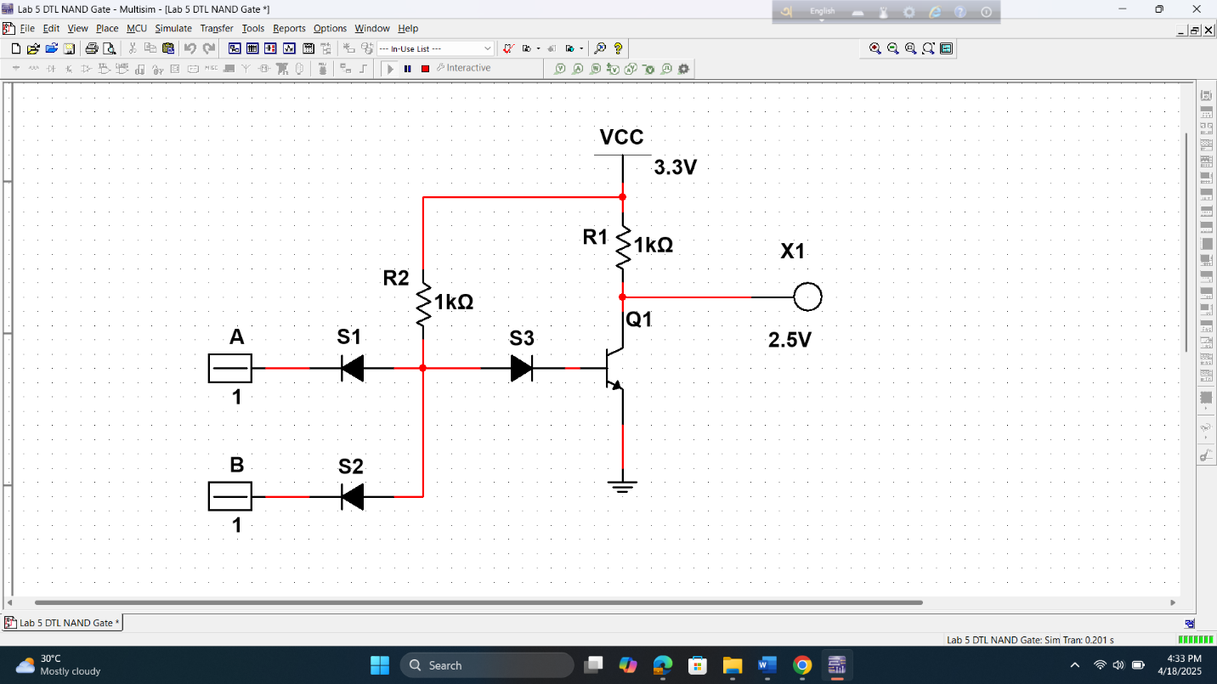

TTL Inverter

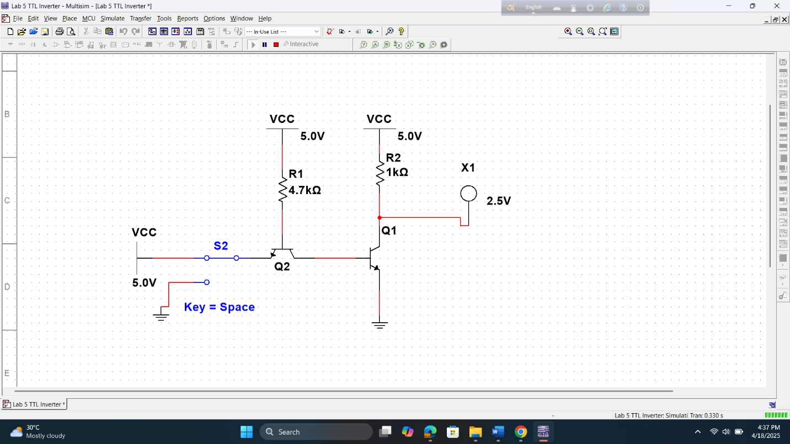

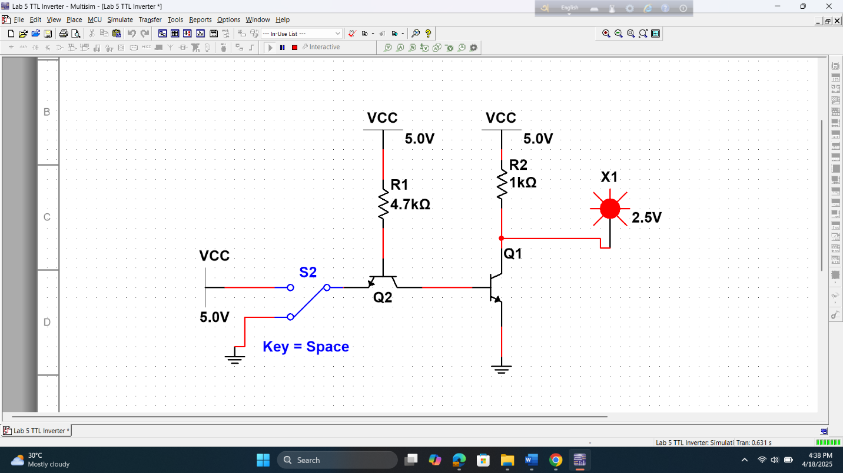

**Results and Discussions:**

In this experiment, we built logic gates using diodes and transistors and tested their outputs. Most results matched the expected truth tables, showing that the experiment was successful. Some mistakes, like wrong wiring or loose connections, affected a few outputs. To improve, we could use simulations and check circuits more carefully. Overall, it was a good learning experience.

# Report:

1. For each of the above set-ups, describe in words what the data means. Did your results match the expected ideal outputs? If not, explain why?

**Ans:** For each setup—DL, RTL, DTL, TTL, and ECL—we built and tested logic gates, then compared outputs to the expected truth tables. In most cases, the results matched the expected outputs. When they didn’t, it was usually due to incorrect wiring, faulty components, or measurement errors. These small issues reminded us how important careful setup and testing are in real circuits.

1. Design a 4-input RTL OR gate and explain its operation.

**Ans:** We connected each input (A, B, C, D) to the base of a transistor. If any input is high, its transistor turns on and pulls the output low, giving us the OR behavior. Proper resistor values are important to bias the transistors correctly. The circuit is simple and works well for demonstrating OR logic with hardware.

1. Design a 3-input TTL NAND and NOR gates and explain their operation.

**Ans:** For TTL NAND: Transistors are set up so that when all inputs are high, the output goes low. If any input is low, the output stays high—classic NAND behavior.

For TTL NOR: Transistors are arranged so that if any input is high, the output goes low. If all inputs are low, the output is high, showing NOR logic.

1. Design a 3-input DTL NAND gate and explain its operation.

**Ans:** diodes do the ANDing of the inputs, and a transistor inverts the output. If all inputs are high, the transistor turns on and pulls the output low. Otherwise, the output is high. This setup combines diode logic and transistor switching.

1. Design a 3-input ECL OR gate and explain its operation.

**Ans:** ECL uses transistors in active mode, not switching. If any input is high, that transistor conducts and pulls the output low. If all are low, the output goes high. It’s super fast because it avoids saturation and switching delays.

1. For all these circuits show their PSPICE/LTSPICE/PSIM Simulations.

**Ans:** To simulate, we drew each circuit in the software (e.g., LTspice), added components like transistors, resistors, and voltage sources, and set values. Then we ran transient or DC simulations to test outputs under different inputs. The waveforms confirmed whether the circuit performed as expected.

### **Results and Discussion:**

In this part, we’ll summarize what we did in the experiment and talk about how well it met the original goal. We’ll look at the results, explain what they mean, and see if they matched what we expected. If there were any mistakes during the process, we’ll mention them and suggest how the experiment could be done better next time.

# Reference(s):

1. Thomas L. Floyd, *Digital Fundamentals*, 9th Edition, 2006, Prentice Hall, India.
2. Boylestad, Robert L. *Electronic Devices and Circuit Theory*. Pearson Education, India, 2009.